Appendix A: Standard Operating Procedure for Quality Control of Data from the Gas Chromatography Flame Ionization Detector

Purpose
The Gas Chromatography Flame Ionization Detector (GC-FID) is utilized for sampling Volatile Organic Compounds (VOCs). This section is intended to serve as a Standard Operating Procedure (SOP) for performing Quality Control (QC) on the data from the GC-FID for heavy compounds (C6-C12) at the San Jose Site. Details on the instrument can be found in the Chromatotec User manual [1].

Scope
This SOP is intended to assist in correcting GC-FID data that has compound misidentification as a result of drift, which occurs naturally due to meteorological fluctuations. It walks through assessing instrument calibration runs, correcting data, and exporting data. It also includes steps for data management, such as exporting to .csv and replacing missing values with ½ MDL. The final section discusses the approximately annual process of reassessing the comparison of the GC-FID with the Gas Chromatography Mass Spectrometer (GC-MS) to ensure compound accuracy, which is recommended to be completed following each manual instrument recalibration.
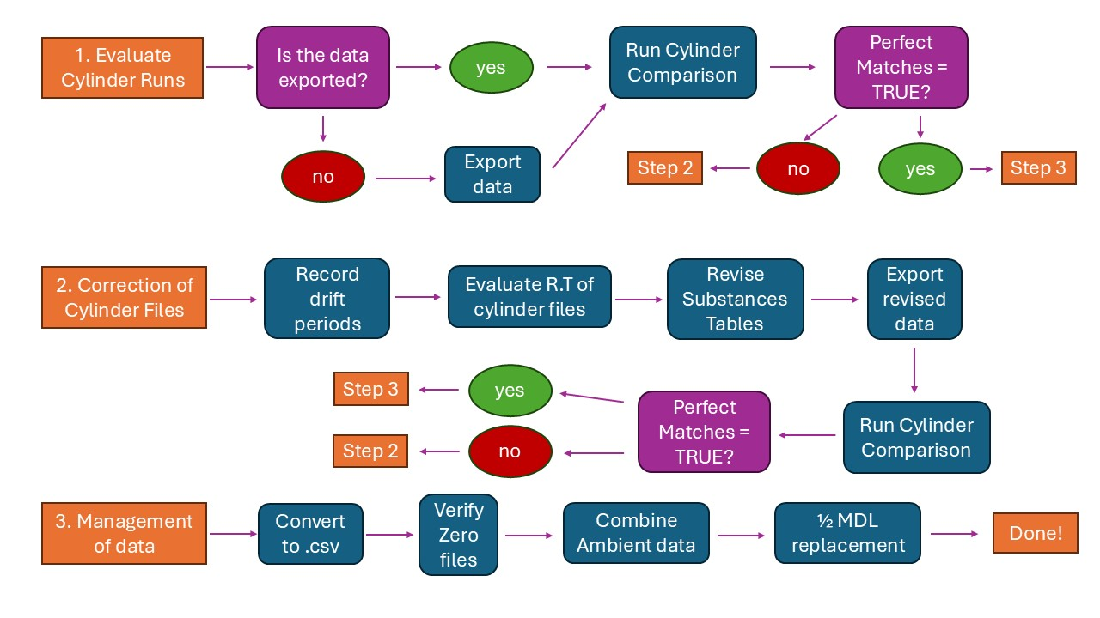Figure 12: Flowchart of GC-FID data QC process

Prerequisites
Prerequisites are as follows:
- Access to the Vistachrom Peak Viewer and Method Manager software
- R (& optional Python) coding software
- Data in “.Chrom” format for the timeframe you intend to correct

Reference Documents
Code (R and Python) and supplementary files can be found here: https://github.com/miraculouswangdoodle/San_Jose_Alb_NM_VOC_Analysis_2025
Files include:
- Templates
  - Managing calibration dates: Date_Tracking_Template.docx
  - Assessing drift of cylinder runs: EmptyC6C12_Revised1.xlsx
  - Code referenced cylinder peak list: ID_cyl_peaks.csv
  - Screenshots for cylinder comparison: Reference_cyl.pptx
  - List of MDLs for 34 compounds: MDL_ppb_C6C12_34c.csv
- R code files
  - Assessing cylinder run accuracy: cyl_asc_compare.Rmd
  - Reformatting cylinder correction files: cyl_C6C12_RT_Adjustment.Rmd
  - Combining files by date after export: Combine_processed_data.Rmd
  - Combining just ambient data: amb_data_combine.Rmd
  - Evaluating zero files for anomalies: evaluate_0s.Rmd
  - Replacement of ambient concentrations with ½ MDL: MDL_replacement_keep34.Rmd
- Optional Python Scripts
  - Calibration file folder structure manipulation: calib_ms_organizer.py
  - Cylinder file folder structure manipulation: CYL07A2_organizer.py
  - Date file folder manipulation: date_organizer.py
  - Substances table correction automation: methodmanager_rt_automation.py

Responsibilities
No staff is currently assigned to be responsible for the data correction of the GC-FID.

Procedure

Evaluate Cylinder Runs
- Choose the date range for processing (i.e., 2025/01/01 to 2025/12/31)
  - This should be a date range that has not been processed
  - It can be a date range following the last date that has most recently been processed (i.e., if performing this process once a month, the date range for processing is suggested to be the last month of data, leading to a continuous period of corrected data that can be used for analysis)
  - Choose C6C12 data. There are issues with C2C6 data as of this writing, so C2C6 cannot be validated until the issues have been resolved

Export Data
- If an export for the date range is already present, either as monthly trend files or .Asc files of the format start date to end date (yyyymmdd_to_yyyymmdd), skip to evaluate cylinder accuracy
  - If not, export the date range selected for processing from Peak Viewer to .Asc files using the following steps
  - Open Vistachrom Peak Viewer software
  - Open just cylinder files for the date range
    - File -> Open
    - Navigate to the folder containing cylinder files (they are titled by date and time: yyyymmdd_hhmm_CYL07-A2.Chrom)
    - Select the files with “CYL07-A2” in the name
(there’s 1 every 4 days)
    - Click Open
    - Repeat as needed to open the entire date range
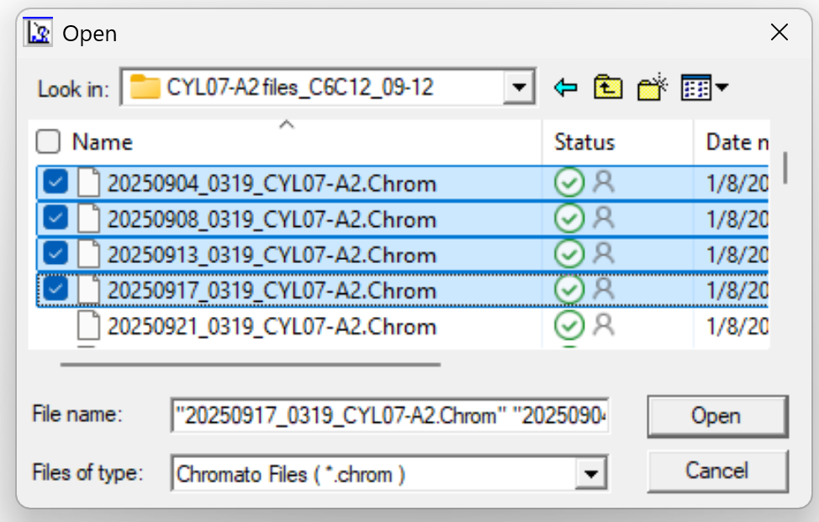
    - Optional: if doing just cylinder files, you can use CYL07A2_organizer.py to consolidate cylinder files for the date range into a singular folder
      - Note: Python must be downloaded and can be opened in IDLE, directly in the console (double click), or any Python workspace
      - Run the Python file
      - Put in path to folder containing folders of months (mm/dd)
      - All files in the period will be stored in a folder with “CYL07-A2 files” in the title in a folder that is one folder back from the given path
  - Go to Post-Process
  - Use the most recent Substances table
    - Click the folder icon under “Substances table used”
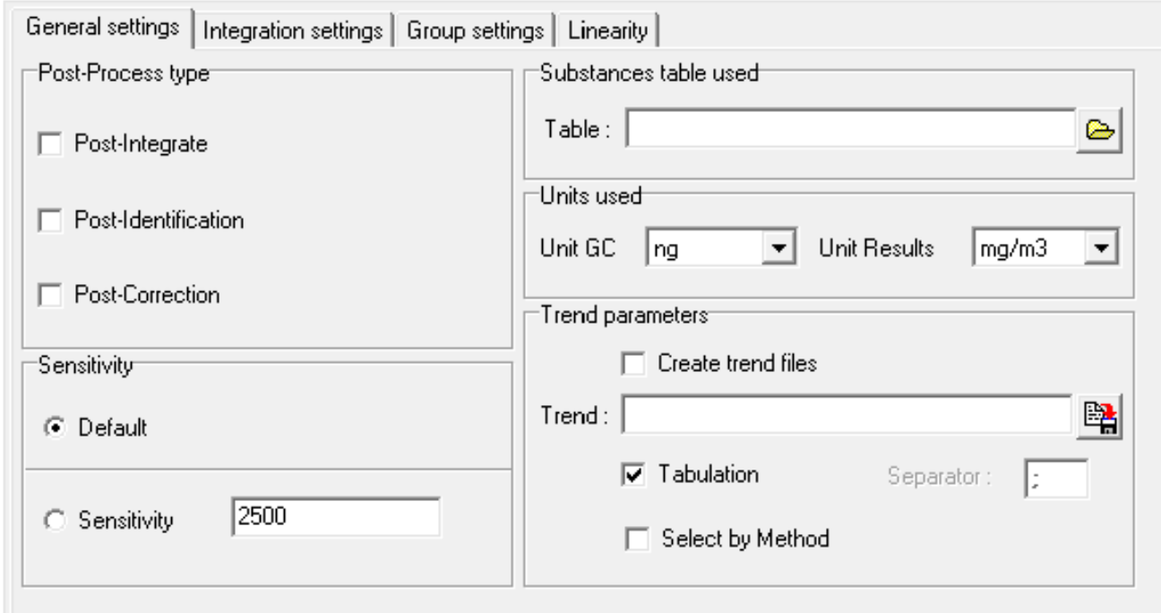
    - Navigate to the folder containing Substances tables
    - Select a Substances table
      - Preferably, this should be the one most recently used; however, any Substances table available will suffice

  - Under “Units used”, select “Unit Results” as “ppb(v)” (default is mg/m³)
  - Under “Post-Process type”, select “Post-Identification” and “Post-Correction”
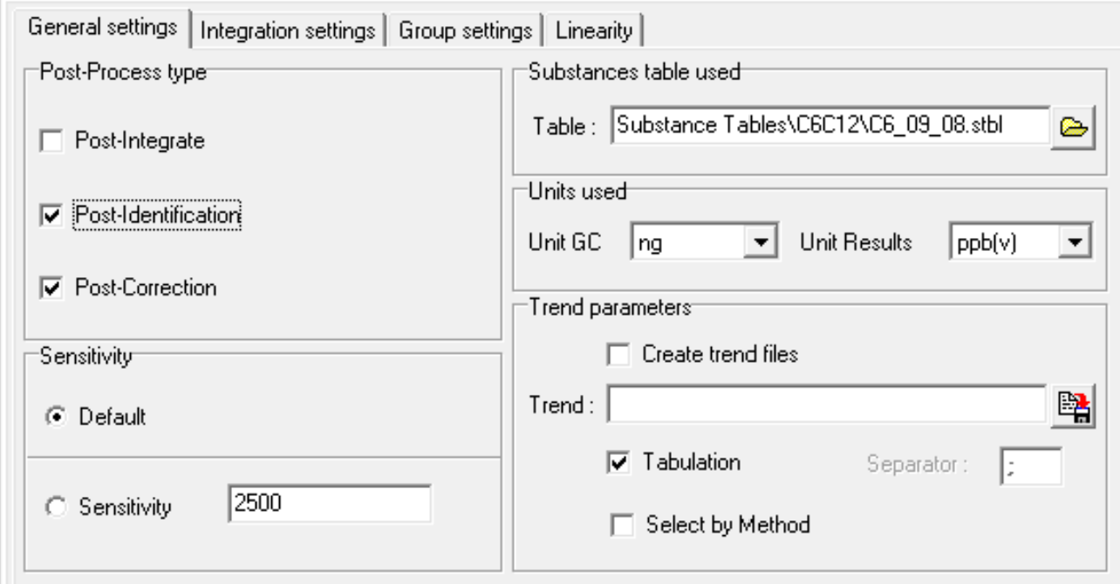
  - Export as Trend files under “Trend parameters”
    - Select “Create trend files” and “Select by Method”
    - Navigate to a new folder in which you want to save your data (save folder) (i.e., a folder named by the time frame you are analyzing)
    - Set the name for the export to startdate_to_enddate as yyyymmdd_to_yyyymmdd
    - Click the Save icon
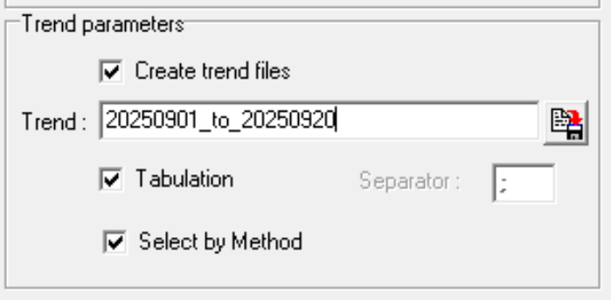
  - Click “Start Post-Process”
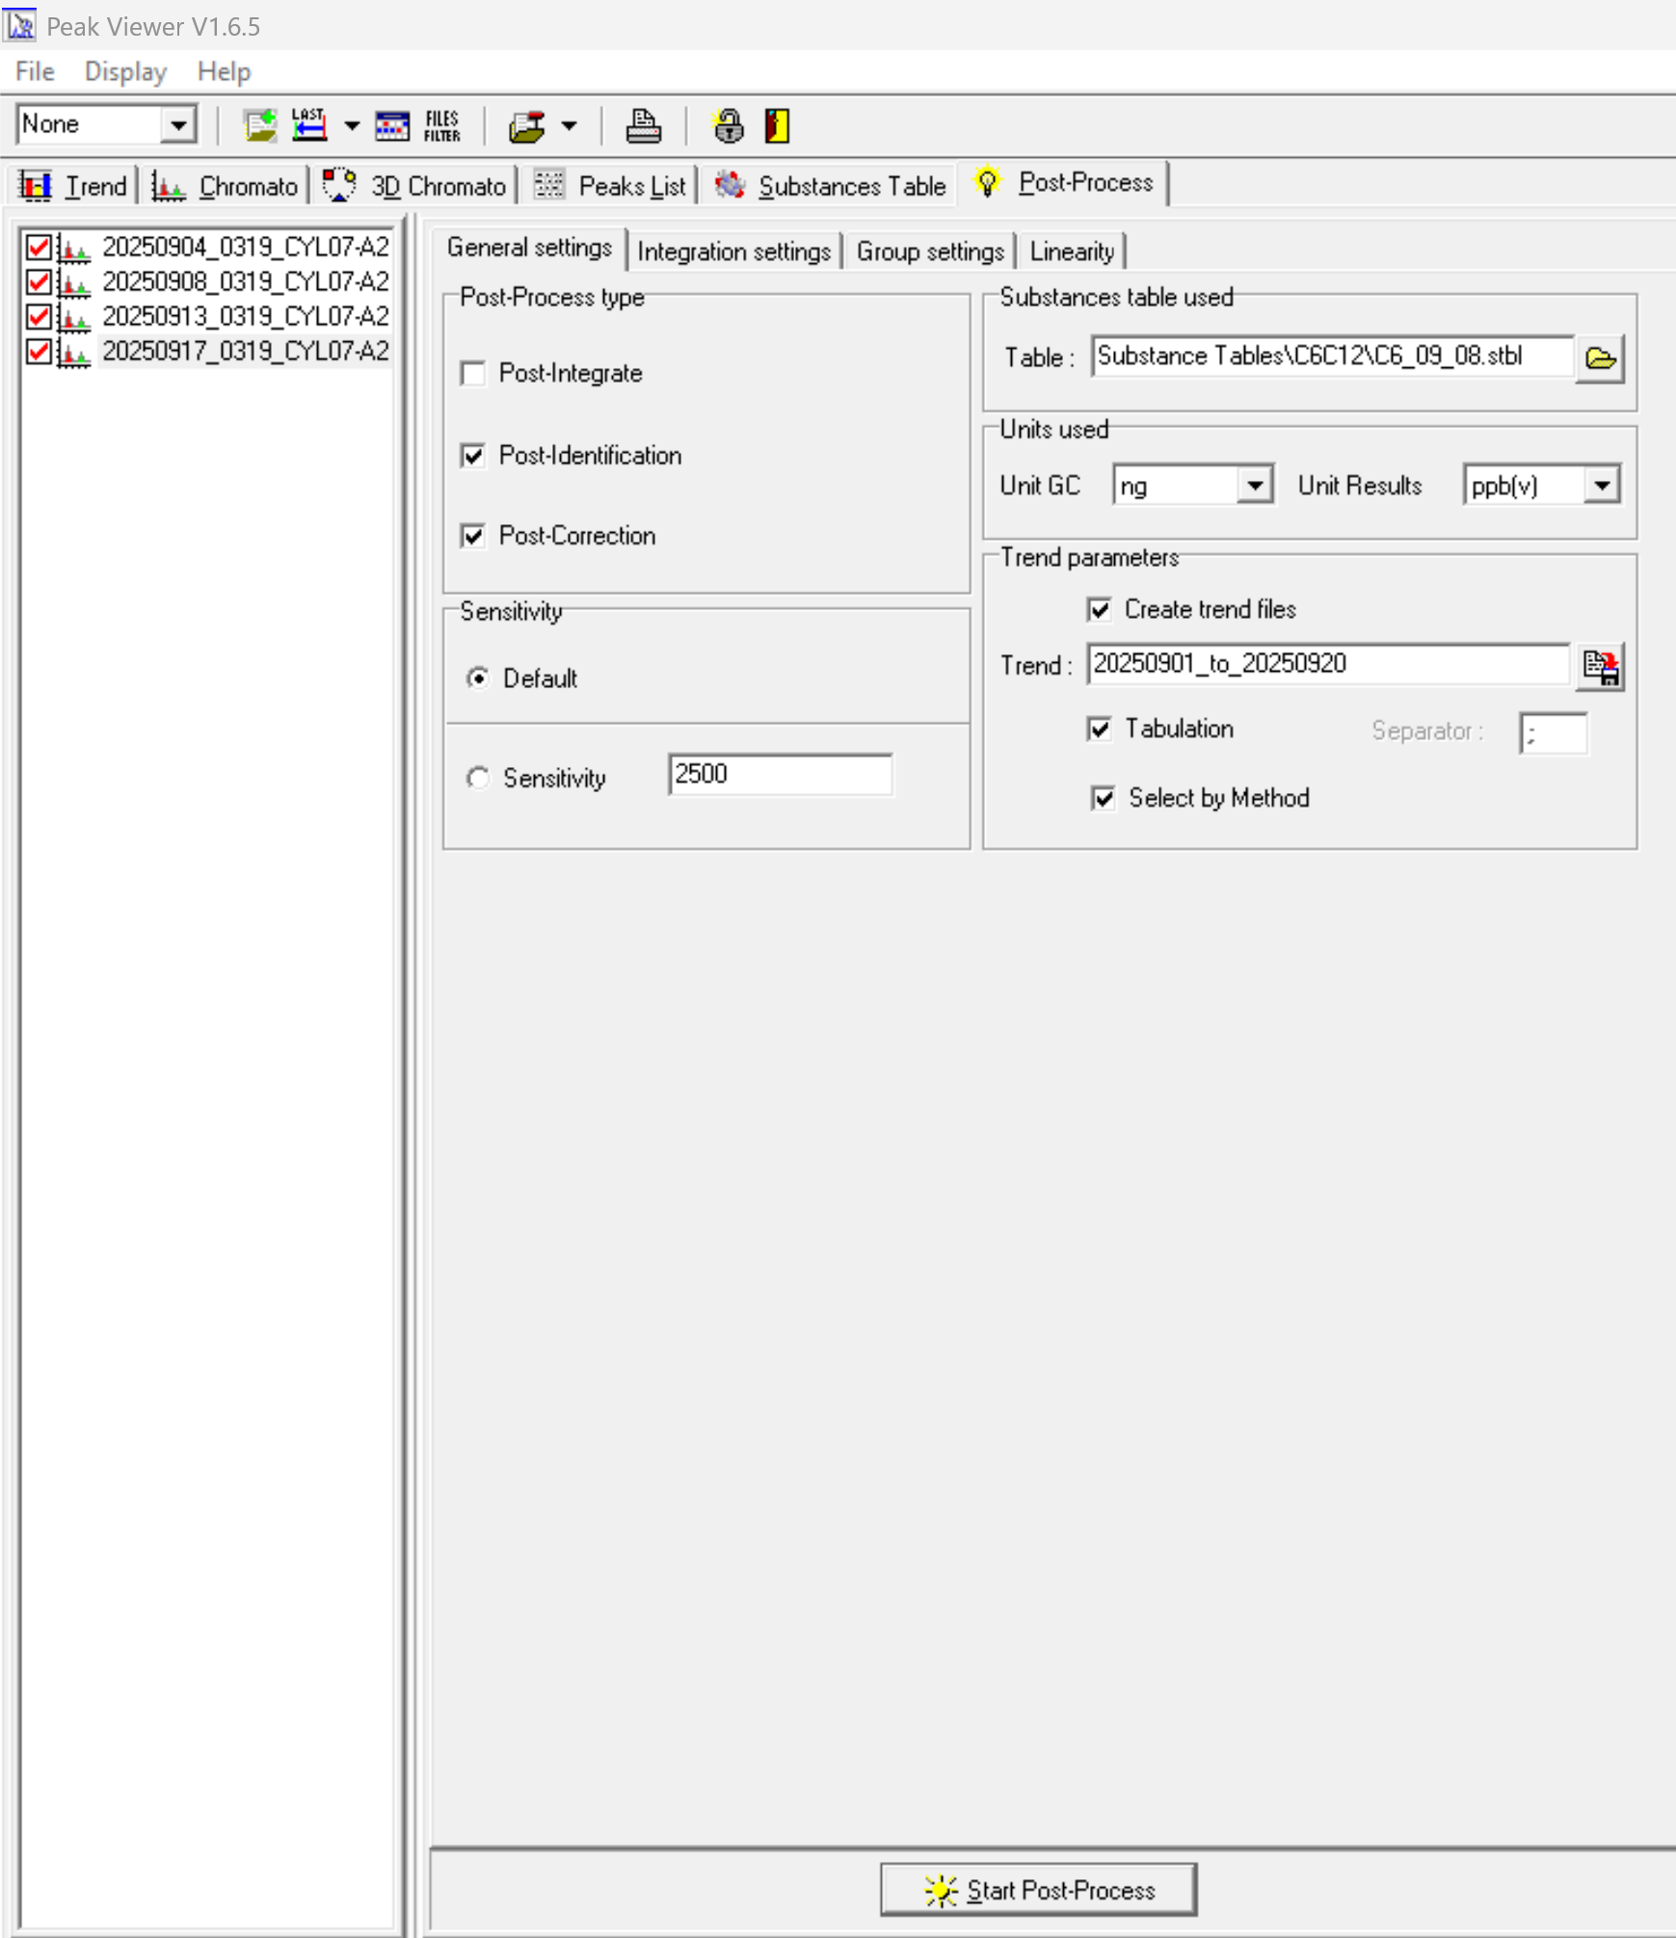
  - If needed, wait for the program to run (i.e., lots of data)
  - Verify that trend files are exported in the save folder
    - Open in File Explorer the folder you made to save your data
  - Close Vistachrom Peak Viewer software

Check Cylinder Accuracy
- Evaluate the Cylinder accuracy by checking if each file output matches the expected peak identities
  - Run cyl_asc_compare.Rmd in R Studio
    - Set cyl_folder to the folder path to the save folder where the trend files were exported (line 43)
    - Set reference_file to the path for ID_cyl_peaks.csv file (line 48)
      - Download ID_cyl_peaks.csv from GitHub if needed
    - Set output_folder to either the cyl_folder variable or to a separate folder path (line 53)
    - Set compound_type (i.e., C6C12) (line 56)
    - Press Run All under Run
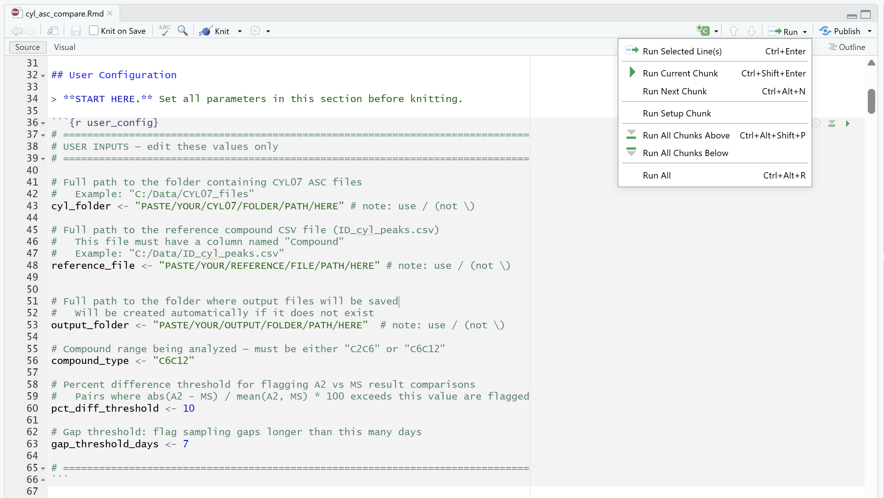
  - Check the comparison report for compound presence
    - Go to your folder with file outputs (the location assigned to the output_folder variable)
    - Open rtime_comparison_report.csv (in output folder)
    - Perfect_match is a logical column that is based on comparing compound names to the list of validated compounds (column F)
    - Unexpected_list is a list of compound peaks that should not be identified but which showed up (column G)
    - Missing_list is a list of compound peaks that should be identified but were not (column H)
    - If perfect_match (column F) shows TRUE, the corresponding cylinder file and data are correct and have all validated compounds and no compounds that are not in the validated list
    - If perfect_match (column F) shows FALSE, the corresponding cylinder file and data are incorrect and has either validated compounds that are not identified and/or compounds present that are not in the validated list
      - Files where perfect_match shows FALSE mean there is a discrepancy in compound identification for the file, and it is assumed to be due to drift, which can be corrected for using the Correction step of this SOP.
      - For each file where perfect_match shows FALSE, revise the relevant Substances tables for the date period that is incorrect
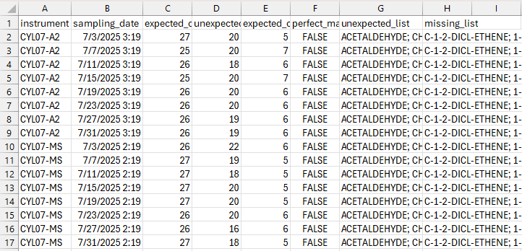
- Do the Cylinder files for the selected timeframe pass with perfect matches? (perfect_matches = TRUE is a pass)
  - If yes, move on to the Management step
  - If no, proceed below with the Correction step

Correction of Cylinder Files

Cylinder File Evaluation
- For all time periods where the cylinder files perfect_match report is FALSE, correct the data in that period using the following steps
- You will review the cylinder chromatographs for the time frame of drift
  - Make a date range table in Word to record drift, using Date_Tracking_Template.docx
  - The file includes columns for tracking dates and times of files
    - From Cylinder: the cylinder file at the beginning of the drift period
    - To Cylinder: the cylinder file at the end of the drift period
    - Representative: the cylinder file that is representative of the period
    - From Calib: the calibration file before the retention time jump
    - To Calib: the calibration file after the retention time jump
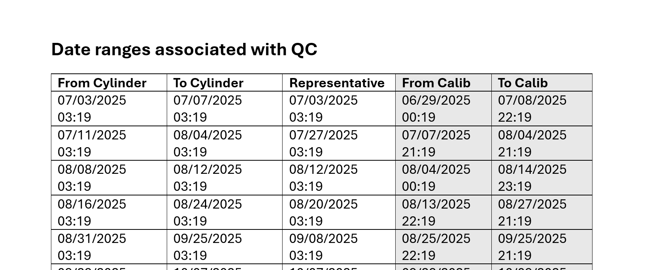
  - Open Vistachrom Peak Viewer software
  - Open all cylinder files for the date range with perfect_match = FALSE
    - For details, see this section under the Evaluate step
  - Go to Chromato view
  - Under Select Display, change it to R. Time
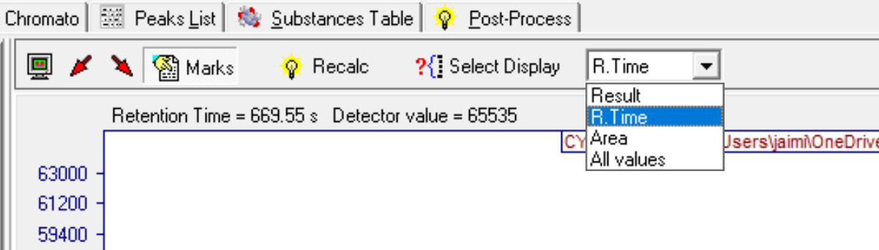

  - Zoom in on any section of peaks (i.e., 400s – 550s)
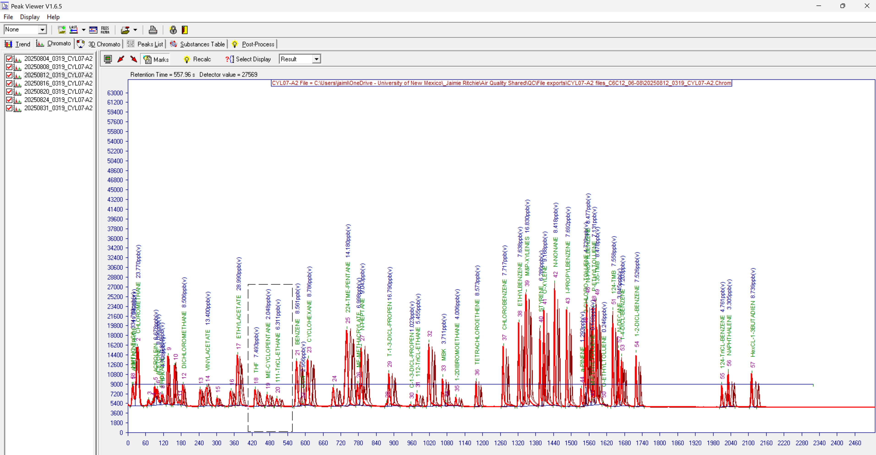
  - Once zoomed in, you will group cylinder files by drift periods, where each period is a continuous time frame without any peaks with greater than a 3-second difference across all files in the time period, as shown by the offset in the location and retention time (R. Time) of peaks
    - You will document groupings for drift in the date range table, Date_Tracking.docx, based on which peaks are grouped together, which can later be corrected by sections of time (i.e., a few days/weeks at a time)
    - Click on the name of the first cylinder in the top left
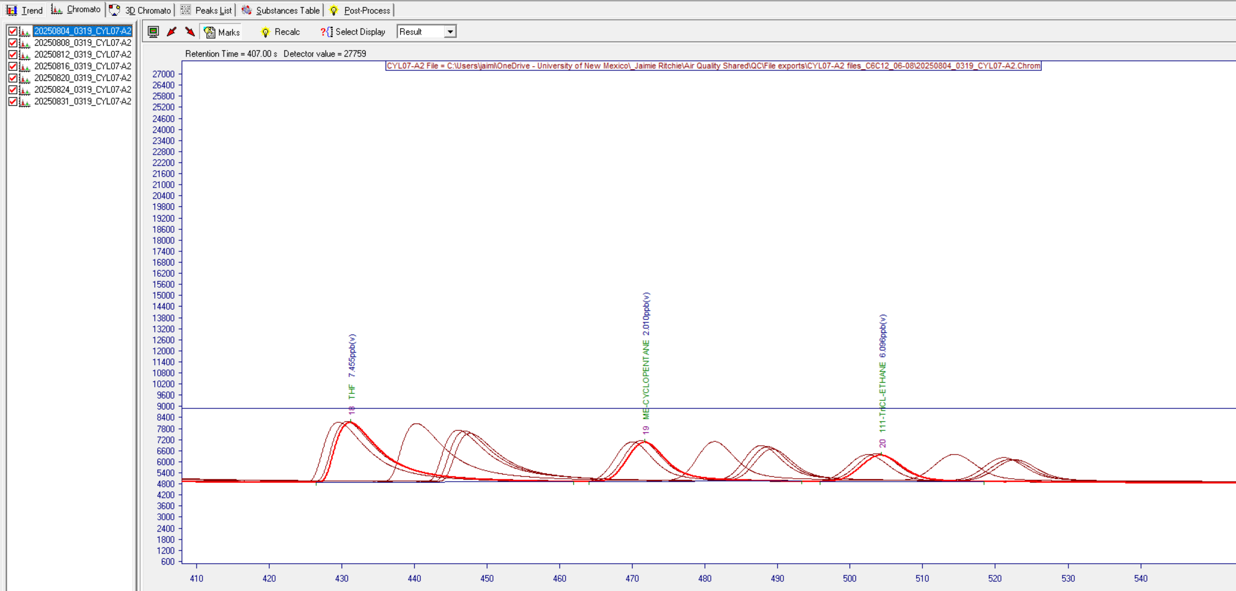
    - Use up and down arrows to scroll between files
    - The highlighted graph represents the current selection
    - Identify cylinder files that are isolated: where cylinder files for dates just before and just after have retention times > 3 seconds different
    - List the isolated cylinder file date & time (from the file name, yyyymmdd_hhmm) in the "representative", "to cylinder", and "from cylinder" columns in the date range table (i.e., 20250831_0319)
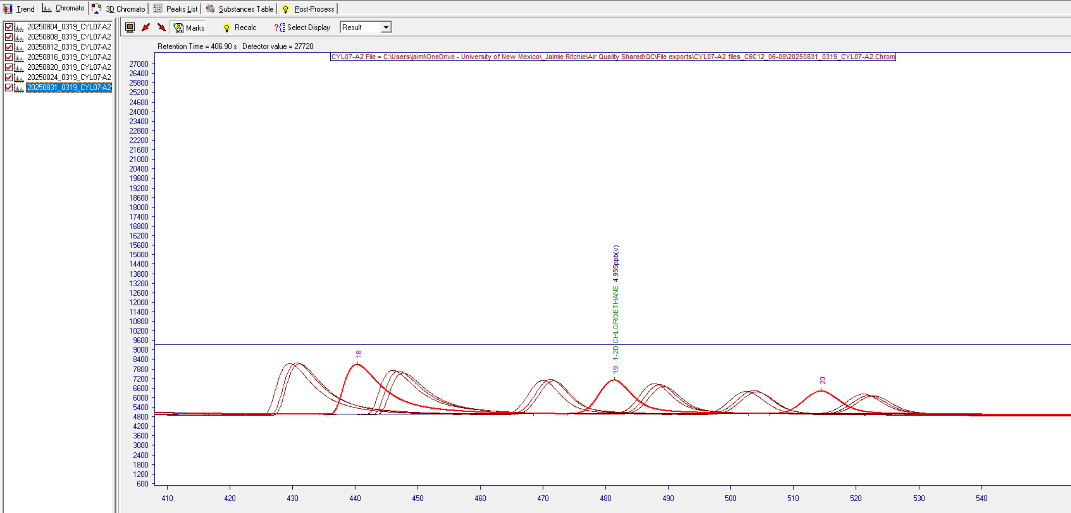
    - You can add columns to the date range table as needed, maintaining an earliest date to latest date order
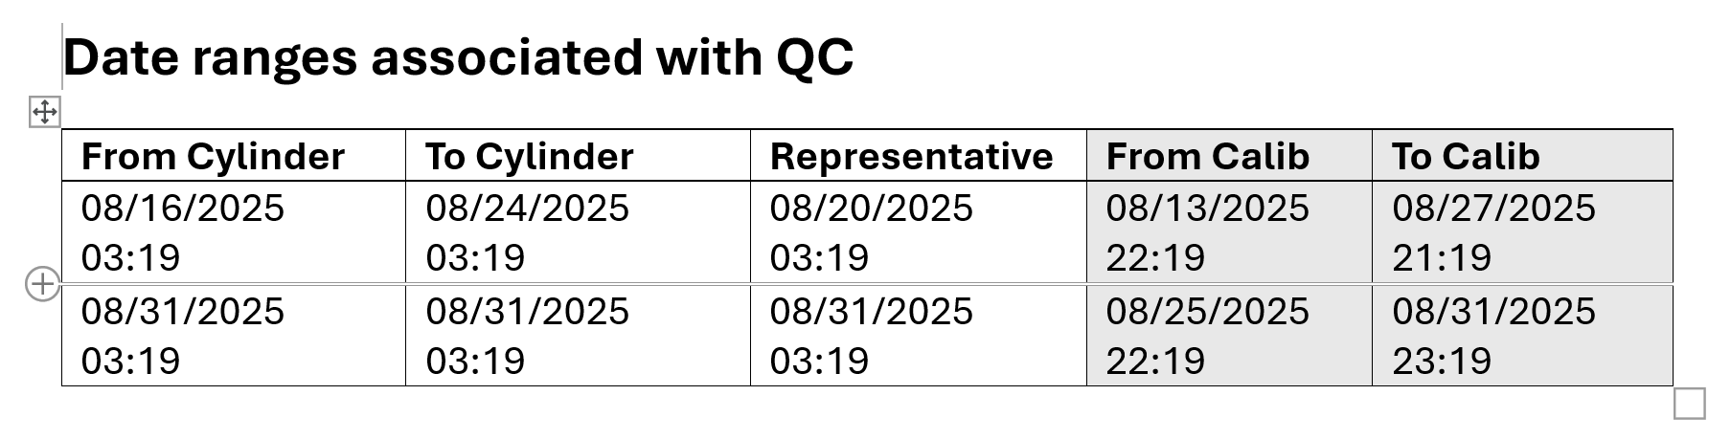

    - Identify cylinder files that are in the visual middle (most central when compared by R. Time) of a grouping (2 or more) of close (< 3-second difference) peaks
      - If there are only 2 files, just choose one
    - List the middle file date & time in the “representative” cylinder files column in the date range table (i.e., 20250820_0319)
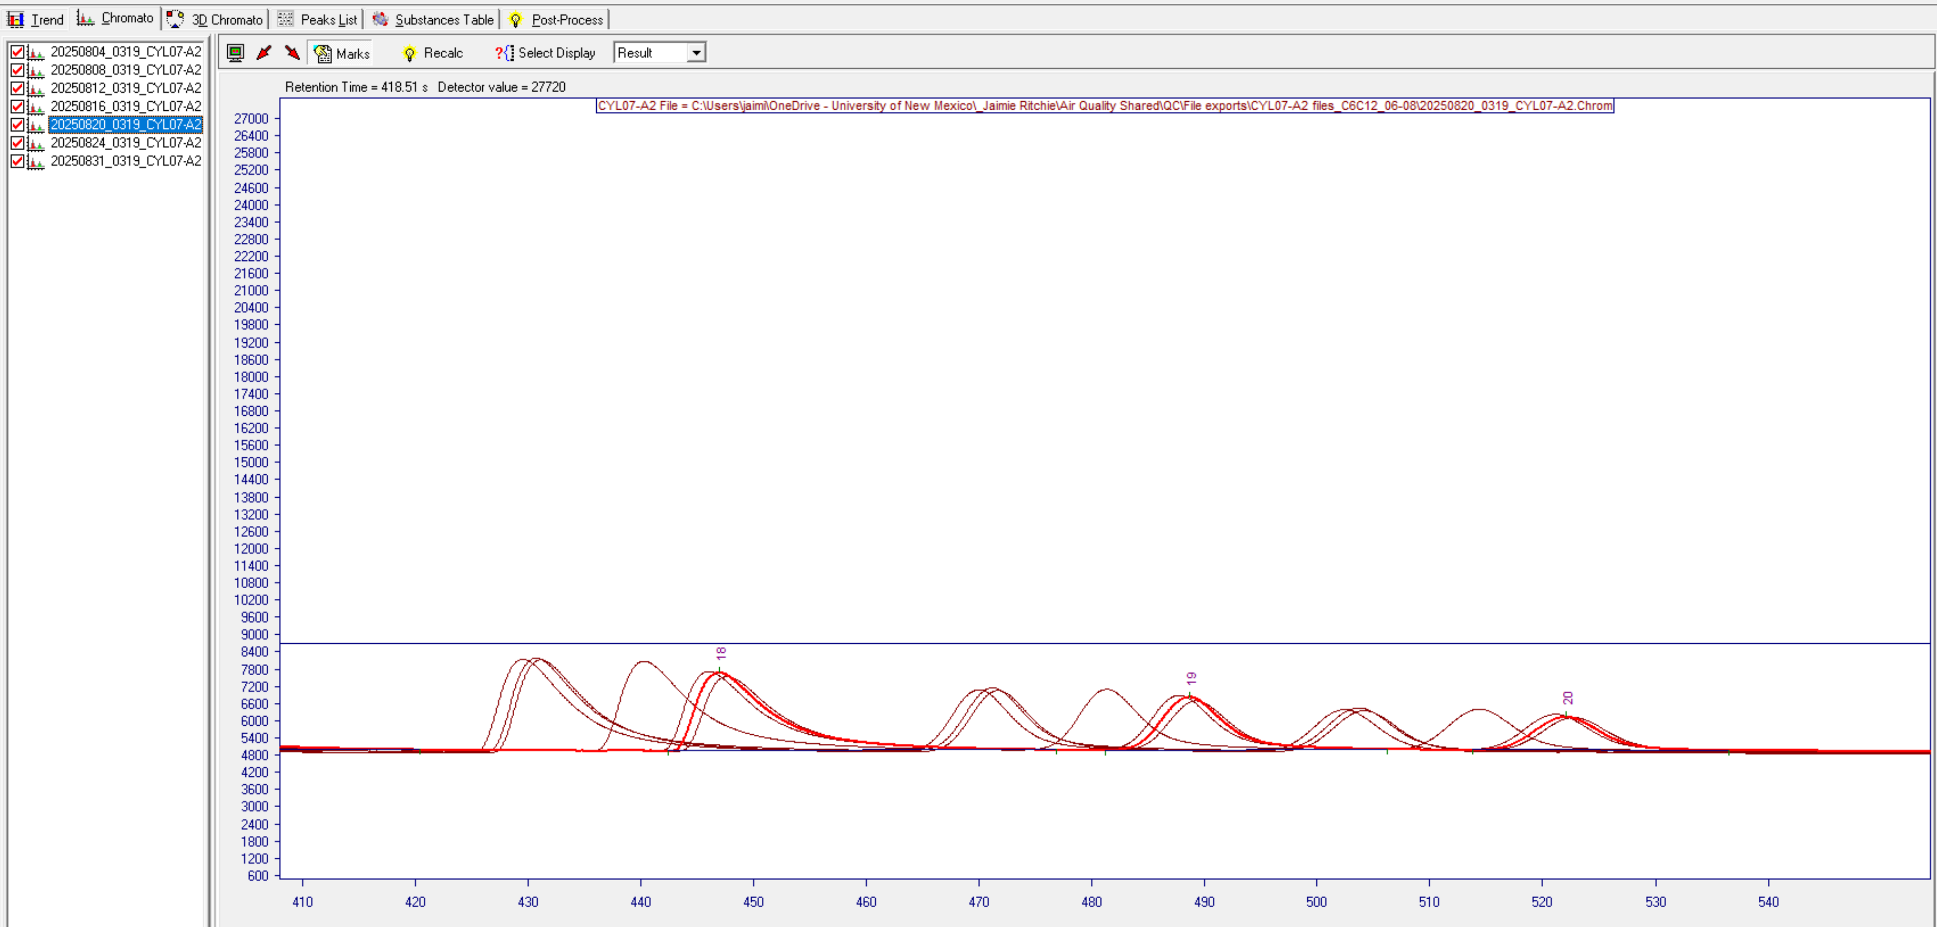
    - Identify the cylinder file that has the earliest timestamp in that grouping (the previous peak is part of a different grouping)
    - List the beginning file date & time in the “from cylinder” column in the date range table (i.e., 20250816_0319)
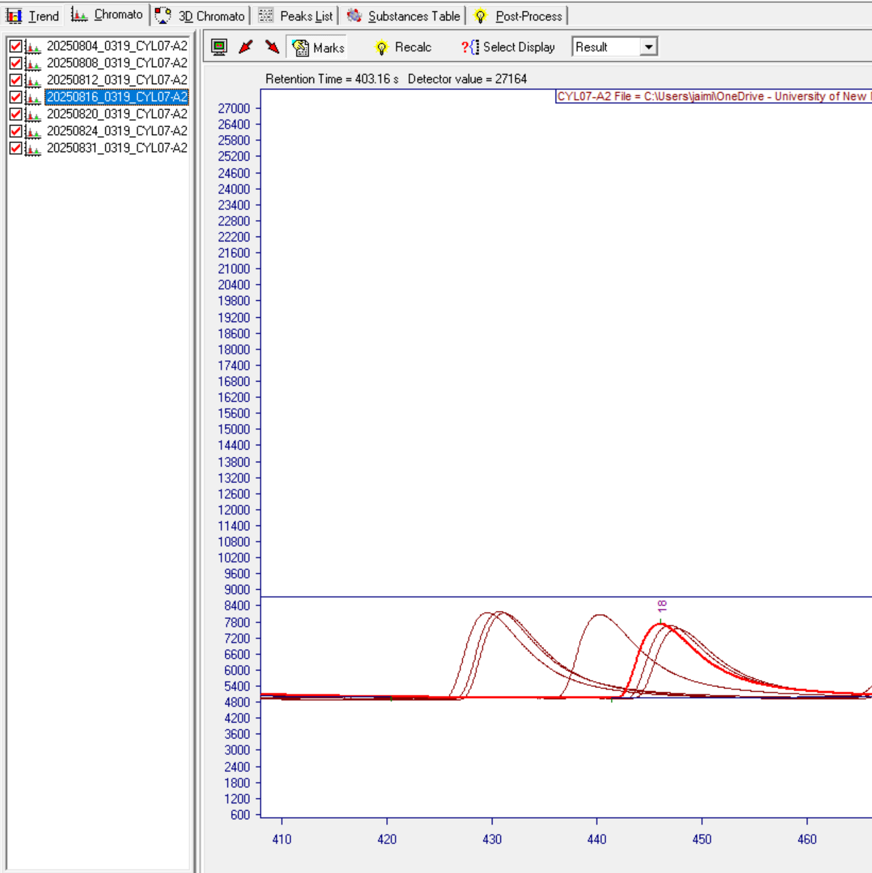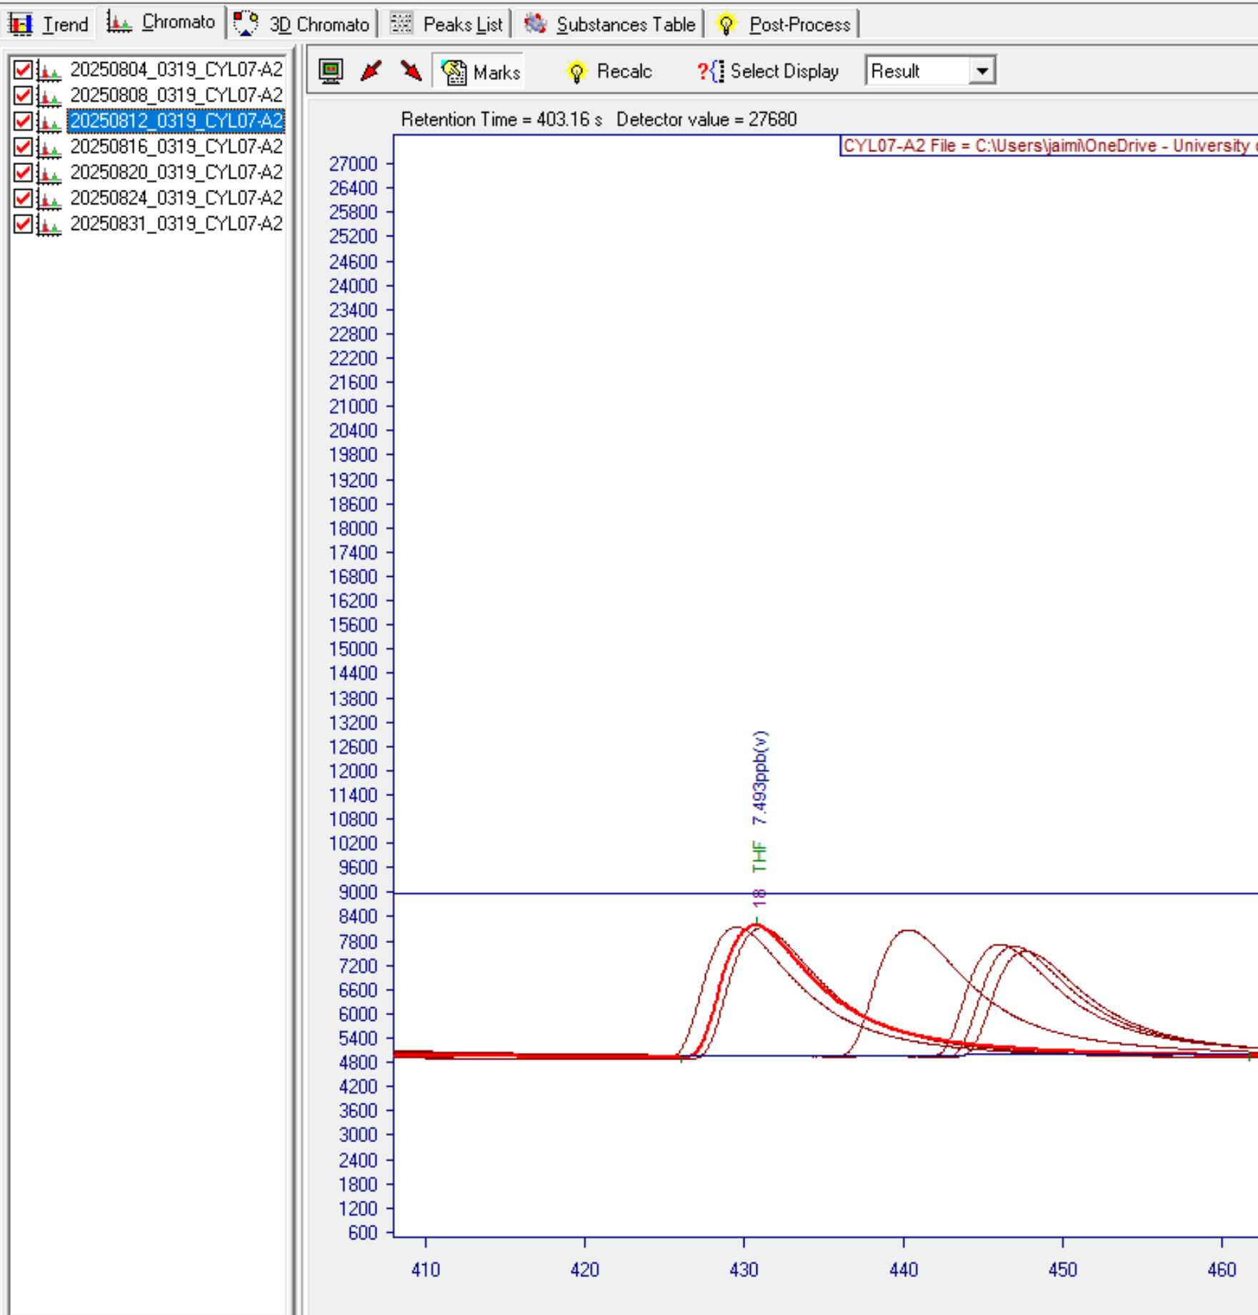
Grouping changes between files
    - Identify the cylinder file that has the latest timestamp of that grouping (the next peak is part of a different grouping)
    - List the end file date & time in the “to cylinder” column in the date range table (i.e., 20250824_0319)
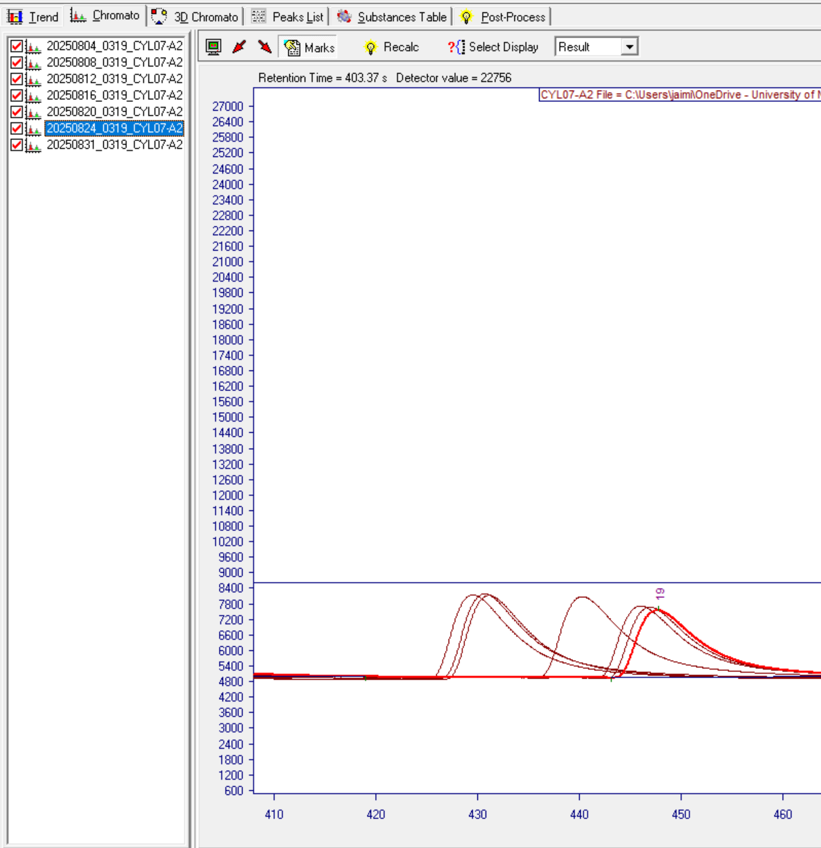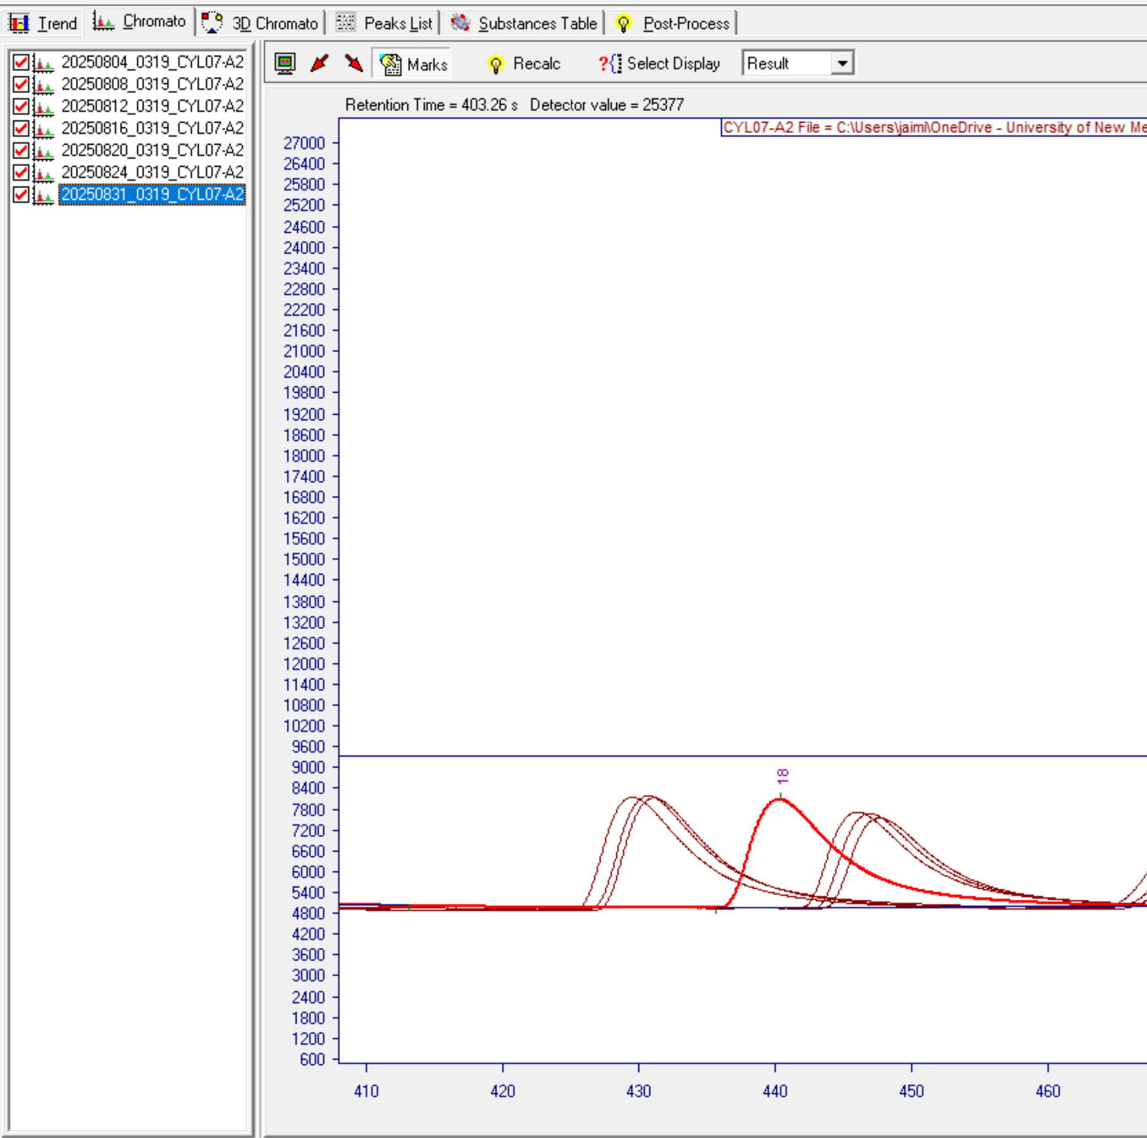
Grouping changes between files
  - Repeat the process until the date range table covers all groupings from the beginning to the end of the date range of interest
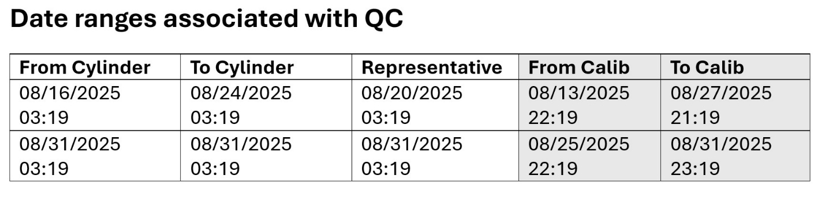

- You will identify the calibration files for the time frame of drift
  - Open all calibration files where dates fall between the cylinder file at the end of one grouping (“to” cylinder) and the cylinder file at the beginning of the next grouping (“from” cylinder) (i.e., calibration files between 8/12/2025 3:19 and 8/16/2025 3:19)
    - Check which dates are the “to” and “from” cylinder
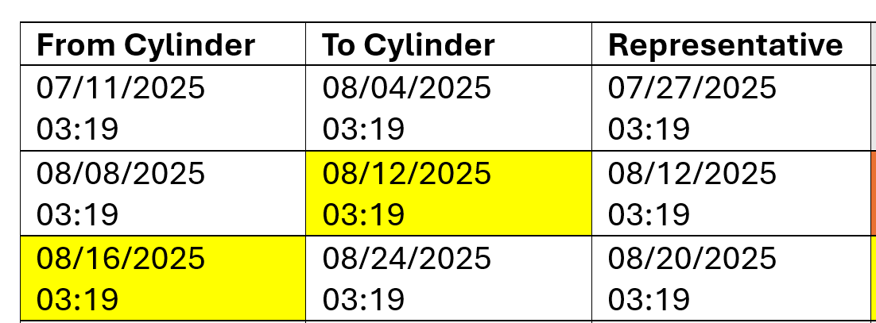
    - Open Vistachrom Peak Viewer software
    - Open calibration files (CALIBMS for C6C12, CALIB60M for C2C6) for the date range (i.e., 8/12/2025 3:19 to 8/16/2025 3:19)
      - File -> Open (Alt+F, O)
      - Navigate to the folder containing the CALIB files
      - Select the “CALIBMS” files from before the date & time in the “To Cylinder” column to the files after the date & time in the “From Cylinder" column
      - Click Open
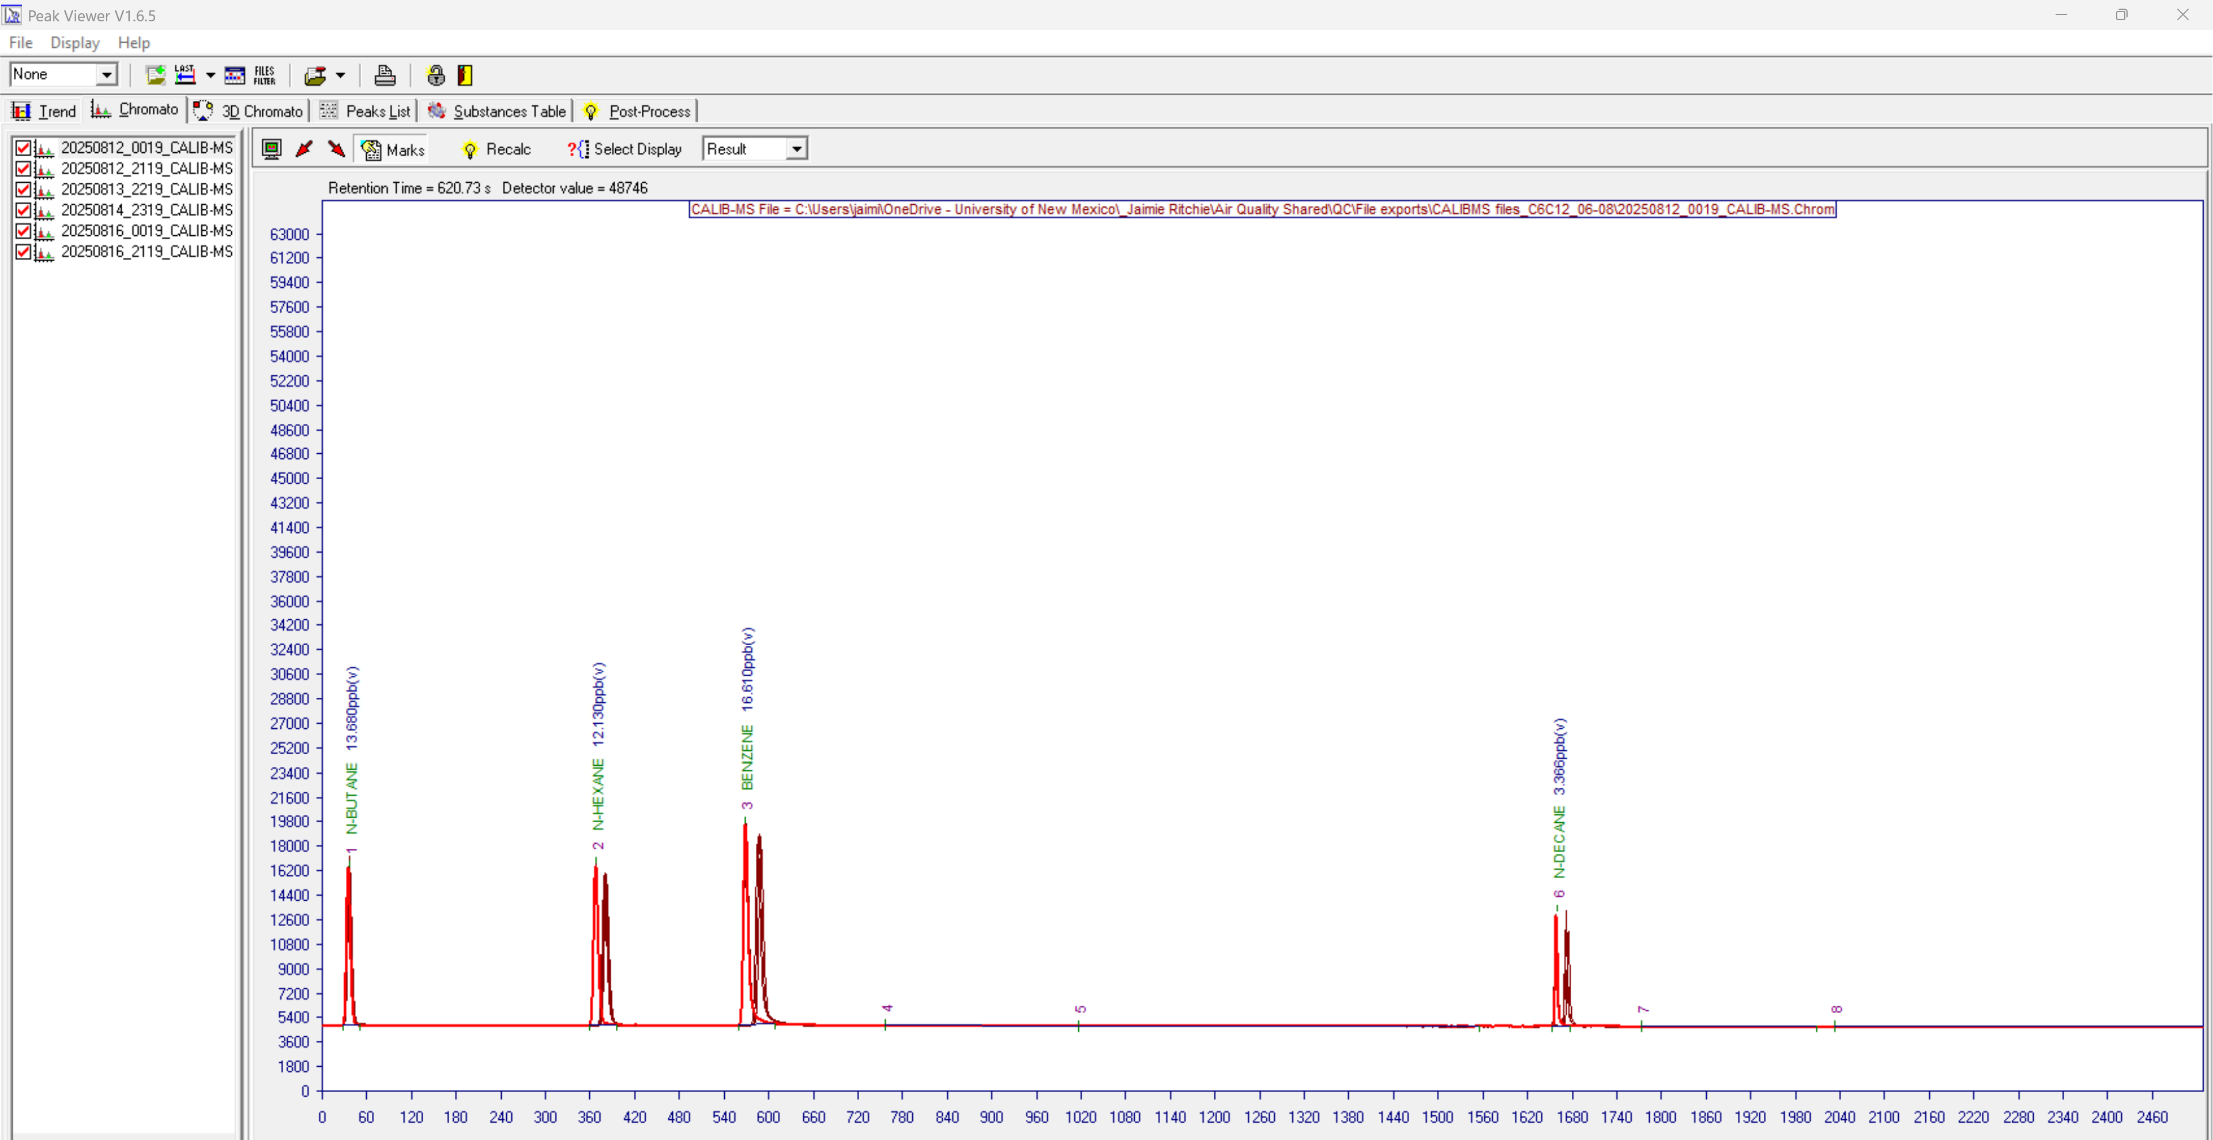
    - Optional: if reviewing just calibration files, use CALIB_ms_organizer.py (for C6C12, 60m version if C2C6) to consolidate calibration files for the date range into a singular folder
      - Note: Python must be downloaded and can be opened in IDLE, directly in the console (double click), or any Python workspace
      - Run the Python file
      - Enter the folder path containing folders of months (mm/dd)
      - All files within will be copied to a folder that is one folder back from the given path
  - You will evaluate calibration files for the point of drift
    - Zoom in on any calibration peak
    - Note the files between which the R. Time changes most significantly in the direction in which the associated cylinder files for that time period change
    - Find the date before the drift/jump occurred (i.e., 20250813_2219)
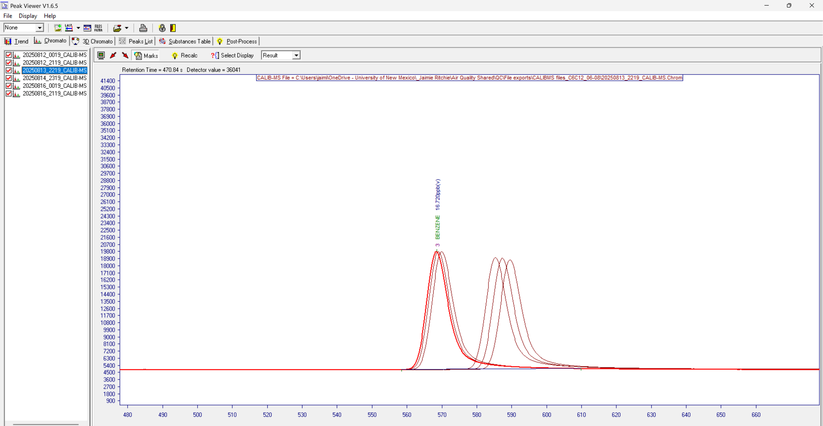
    - Put the date & time in the “From Calib” column of the date range table in the row of the associated “From Cylinder”
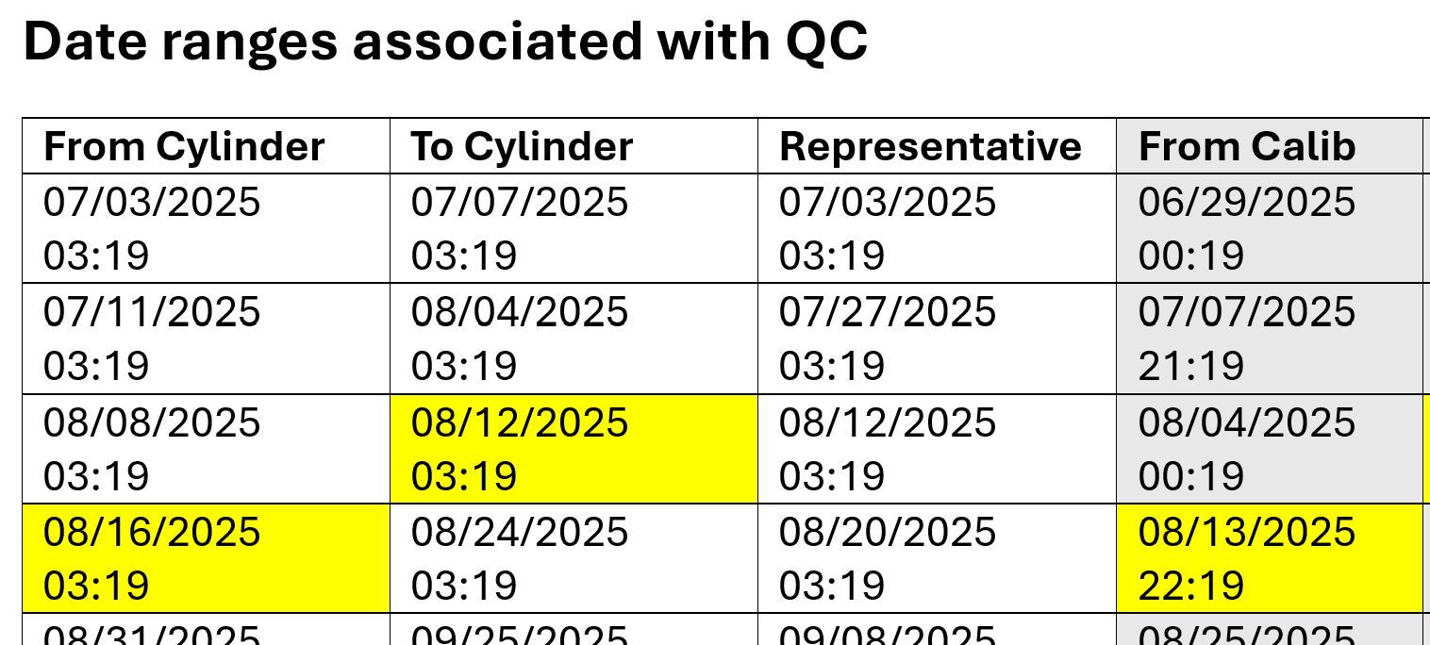
    - Find the date after the drift/jump occurred, which will be consecutive to the previously recorded file (i.e., 20250814_2319)
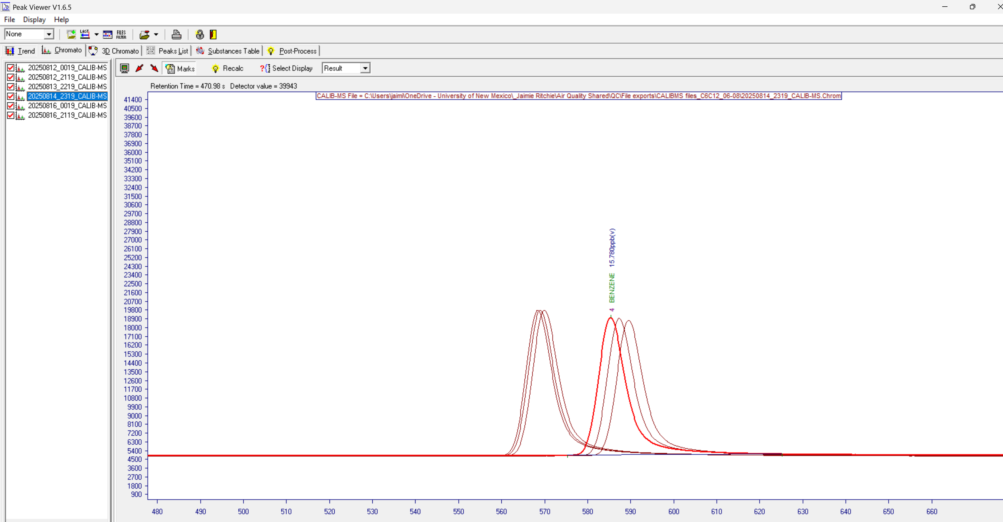
    - Put the date & time in the “To Calib” column of the date range table in the row of the associated “To Cylinder”
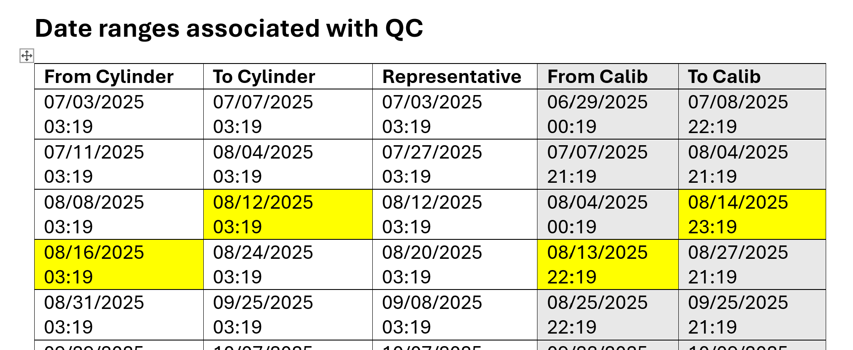
    - Some drift periods may not have a clear option. In that case, choose one of the dates that seems best for the Calib columns
    - The “To Calib” should be the date AFTER the “From Calib.” This is to ensure overlap in ambient exports, which will then be aggregated
    - Repeat until all rows in date range table with “Cylinder” dates have corresponding “Calib” dates
  - Close Vistachrom Peak Viewer software

- You will record retention times in an Excel sheet for each file in the “Representative” column of the date range table
  - There will be a separate Excel file for each cylinder file corresponding with a date & time in the “Representative” column of the date range table
  - Make the Excel sheet to record retention times
    - Open the most recent version of EmptyC6C12_Revised.xlsx
      - If you are doing C2C6 use that sheet instead
    - Go to File -> Save As
    - Rename the file as compoundtype_yyyy_mm_dd
    - Set the save location to the preferred folder
    - Click Save
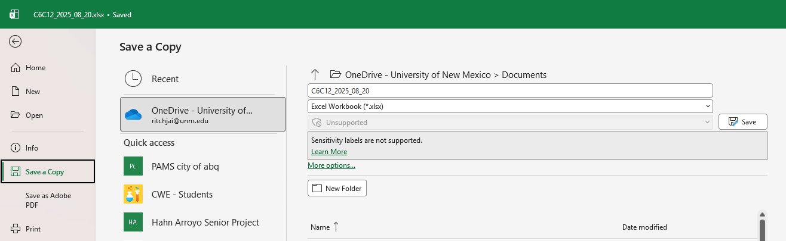
    - Put the date after Substances Table Date (cell C1)
    - The main column you will change is the orange-highlighted R. Time column (in the “valid” sheet)
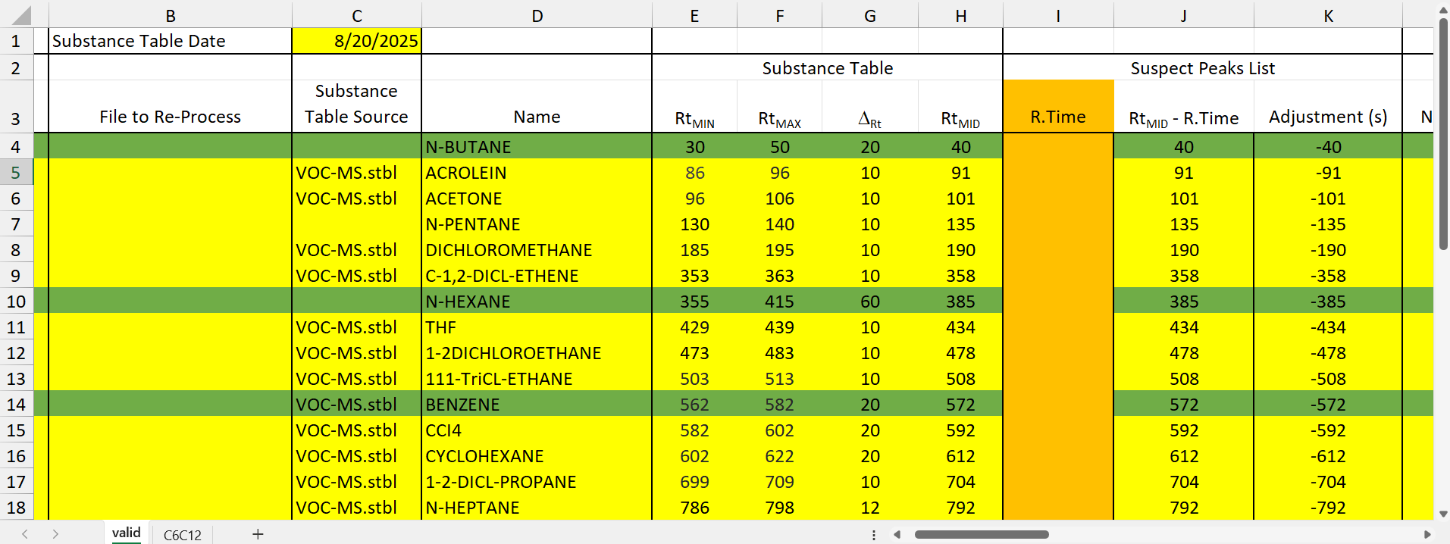
  - Open Vistachrom Peak Viewer software

  - Open the representative file for the date range
    - File -> Open (Alt+F, O)
    - Navigate to the folder containing the file
    - Select the representative file
      - The one with the date & time that aligns with what is listed in the “Representative” column of the date range table
    - Click Open
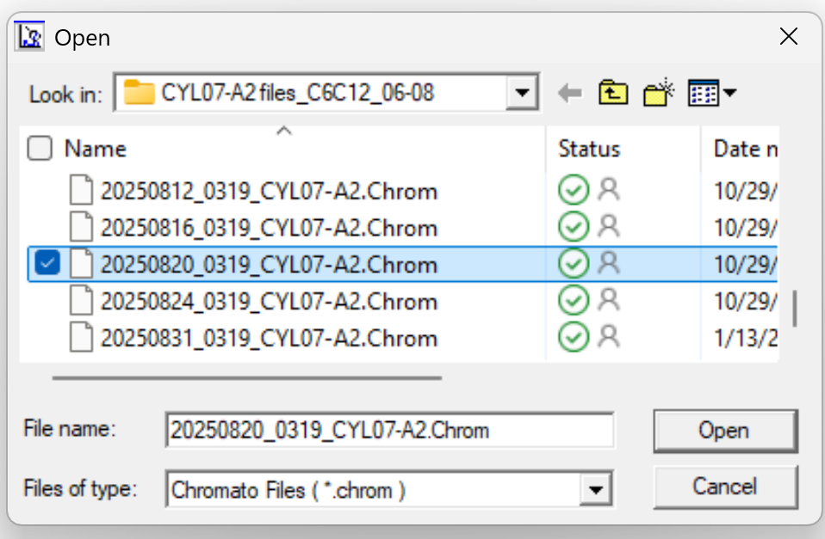
  - Go to Chromato view (C)
    - Under Select Display, change it to R. Time


  - Review chromatographs in sections
    - Refer to the example screenshots in Reference_cyl.pptx
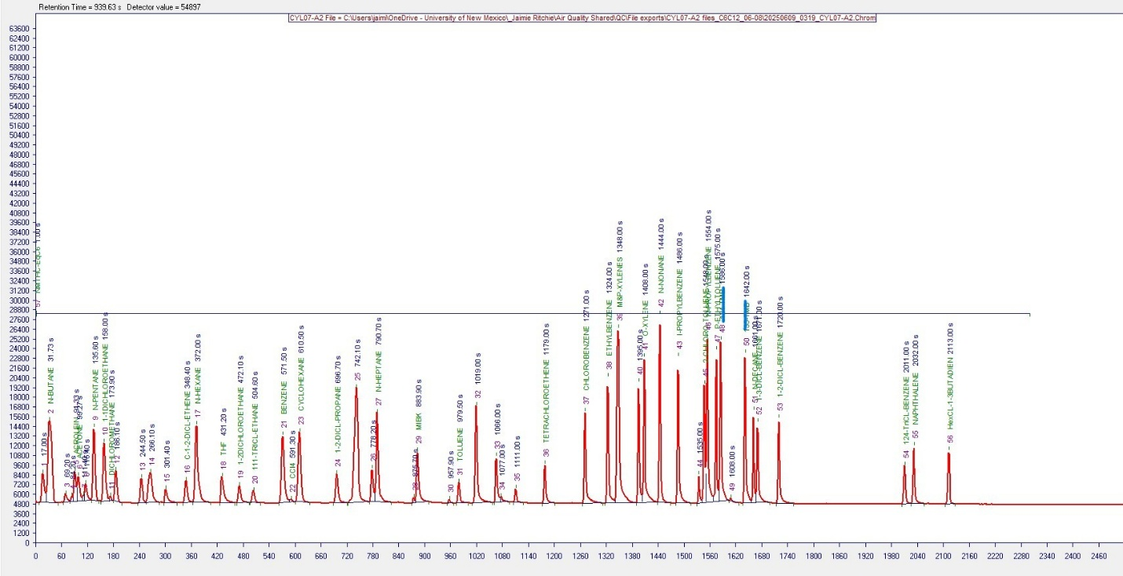
    - Record retention times for the peaks that visually match the appearance of the labeled peak in the screenshot under the corresponding label in the Excel sheet
      - You will note the peaks labeled in the reference screenshots below (i.e., the first is labeled in the picture as N-BUTANE)
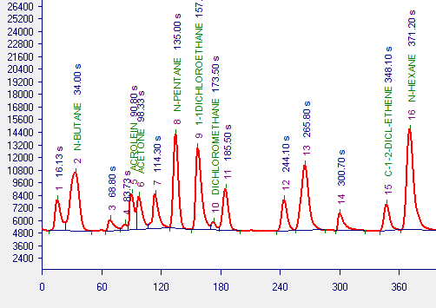
      - Identify defining features of that peak and how it relates to the nearby peaks (i.e., the second peak from the right that is larger than the first)
      - Find the peak that visually matches the peak pattern of a peak that is labeled in the picture, aside from if it is labeled as a different compound or has no label (i.e., CHLOROMETHANE)
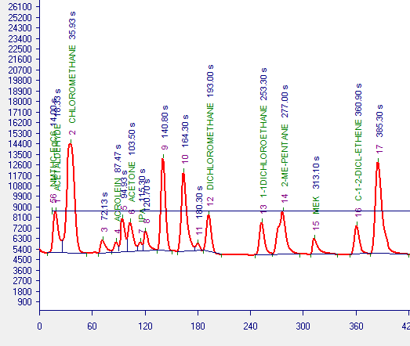
      - Record the retention time listed next to it in the chromatograph (i.e., 35.93 s) in the R. Time column of the Excel sheet
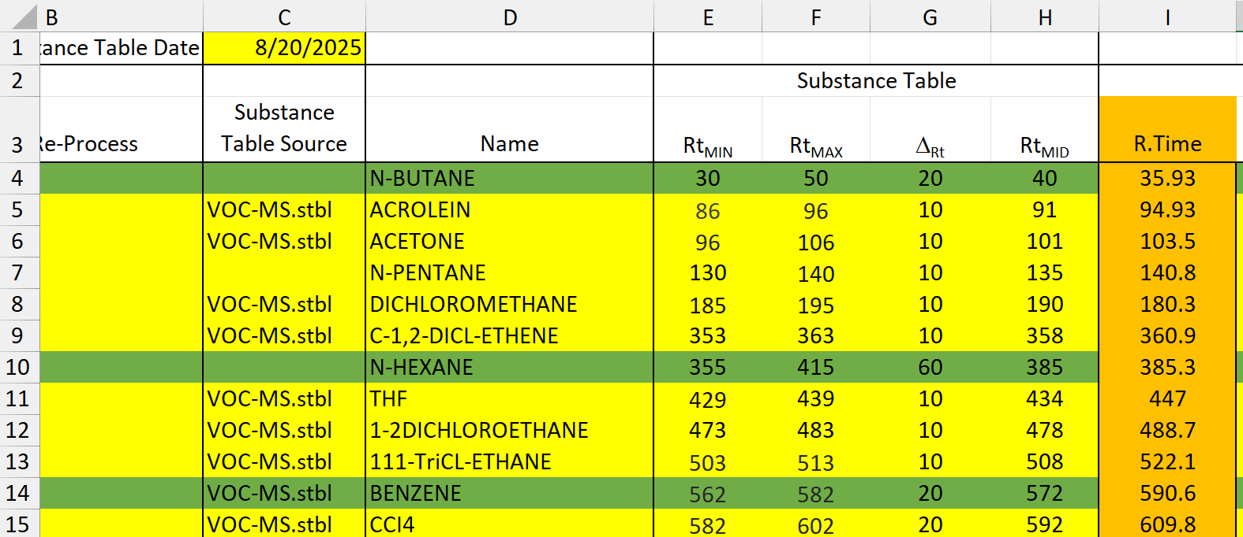
    - Zoom in to 0 – 420 seconds,
    - Compare to the corresponding screenshot in Reference_cyl.pptx
    - Record retention times in the R. Time column of the Excel sheet
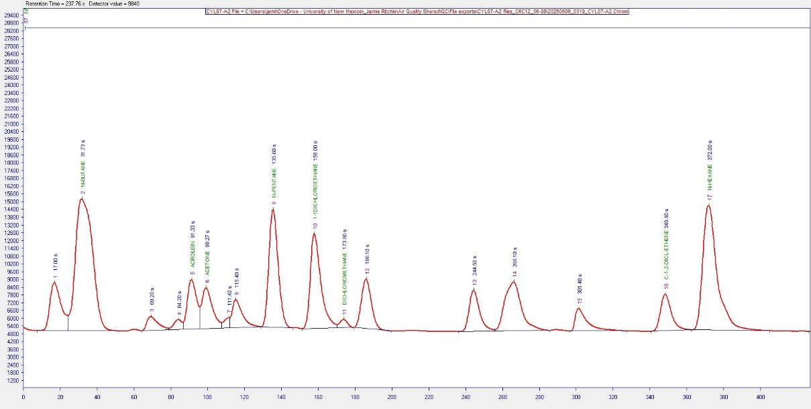
    - Zoom in to 420 – 950 seconds
    - Compare to the corresponding screenshot
    - Record retention times in the Excel sheet
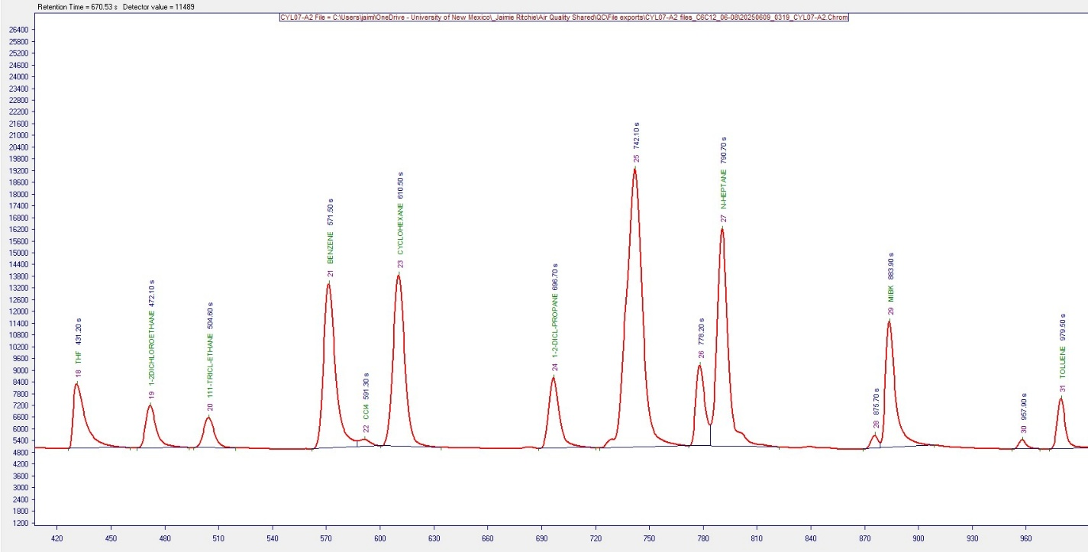

    - Zoom in to 950 – 1240 seconds
    - Compare to the corresponding screenshot
    - Record retention times in the Excel sheet
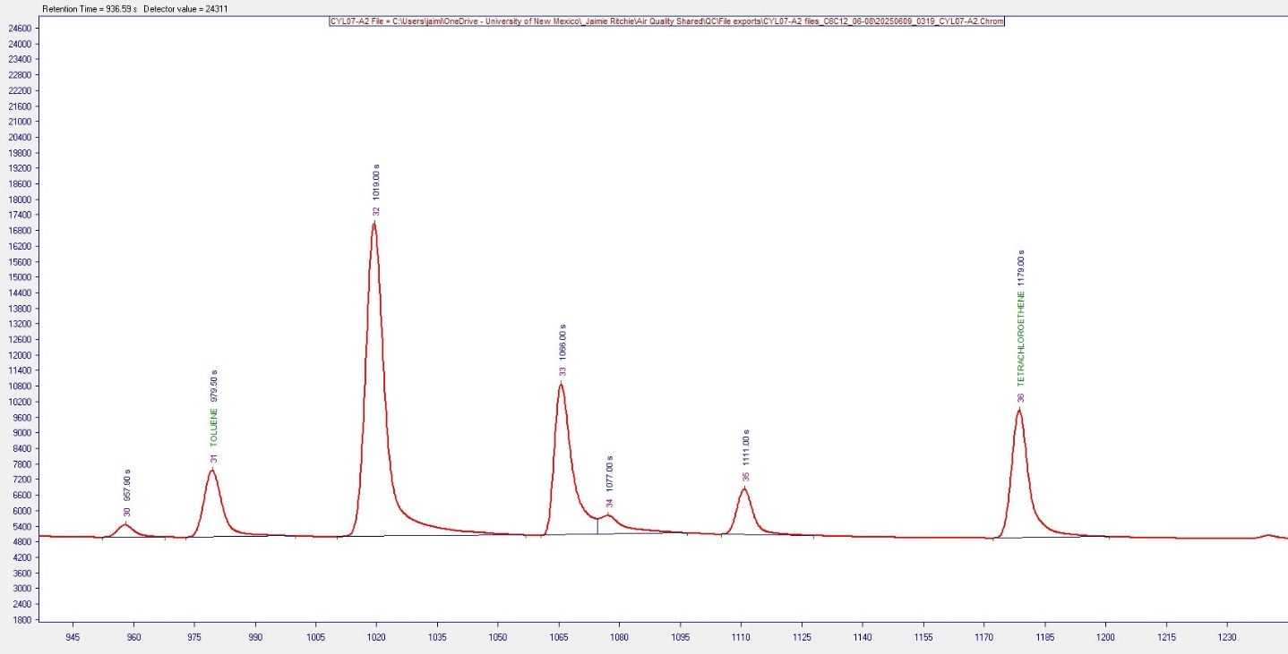
    - Zoom in to 1240 – 1820 seconds
    - Compare to the corresponding screenshot
    - Record retention times in the Excel sheet
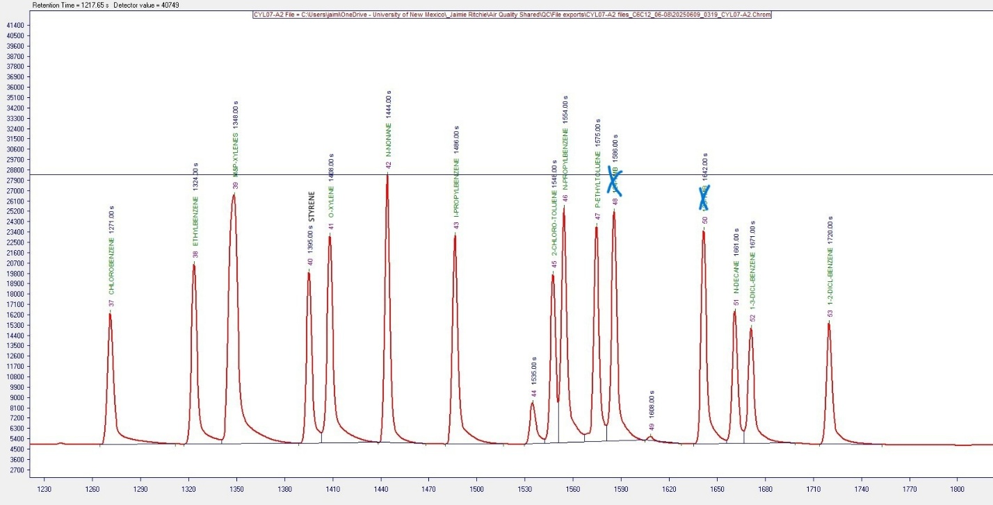

    - Zoom in to 1820 – 2450 seconds
    - Compare to the corresponding screenshot
    - Record retention times in the Excel sheet
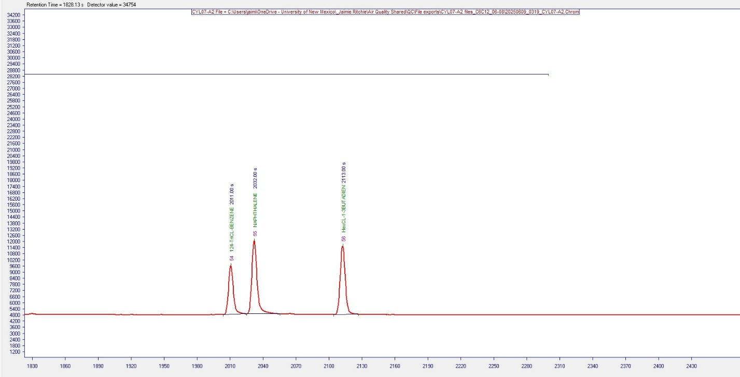
    - Save the spreadsheet with R. Time numbers
  - Repeat the retention time recording process until all representative cylinder files listed have a corresponding Excel sheet with retention times
  - Close Vistachrom Peak Viewer software

- Optional: if you plan to use the Python automation for making Substances tables, make the files acceptable for the shortcut code
  - Open cyl_C6C12_RT_Adjustment.Rmd in R Studio
  - Set the input_dir variable to the path to the folder containing the Excel files of retention times for each compound for various dates (line 77)
  - Press Run All under Run
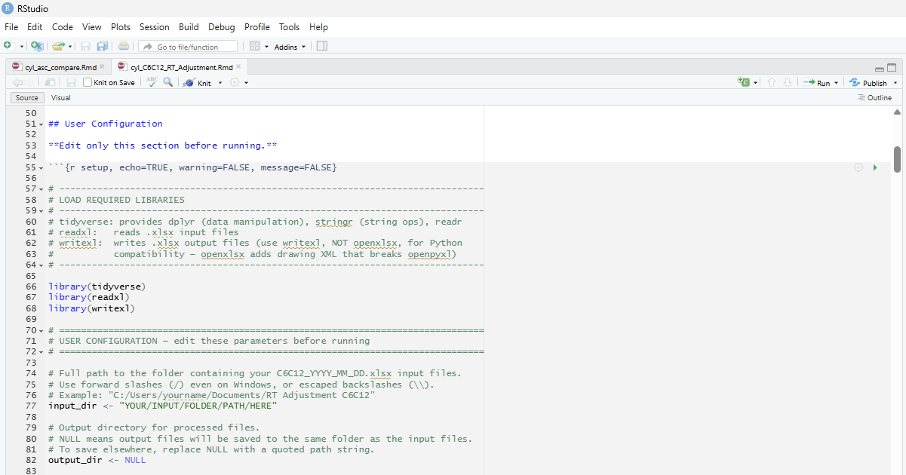
  - Files will be exported as C6C12_yyyy_mm_dd_all.xlsx to the folder

Substances Table Revision
- You will edit new Substances tables corresponding to each Excel file
  - Open Vistachrom Method Manager software
  - Login as SUPERUSER
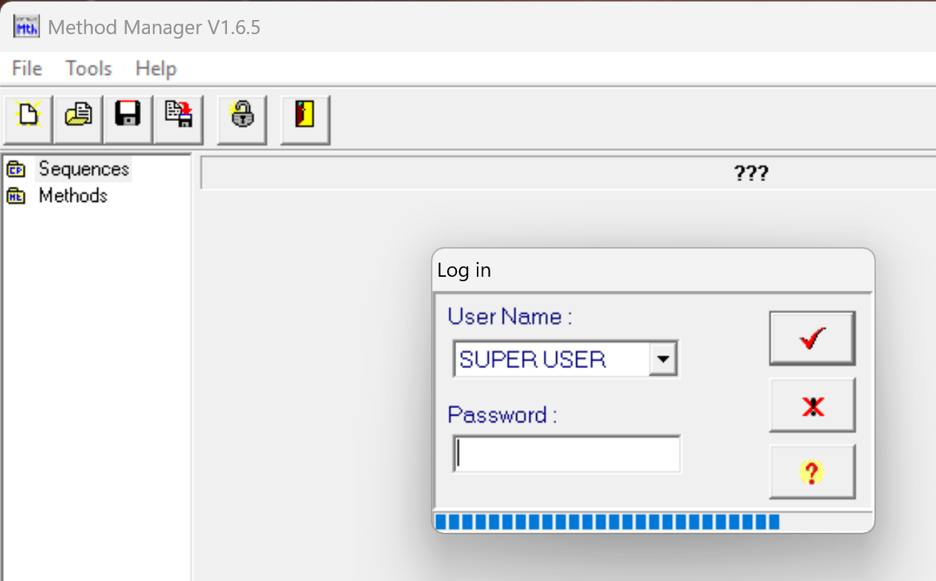
  - Click the Open button (or File -> Open)
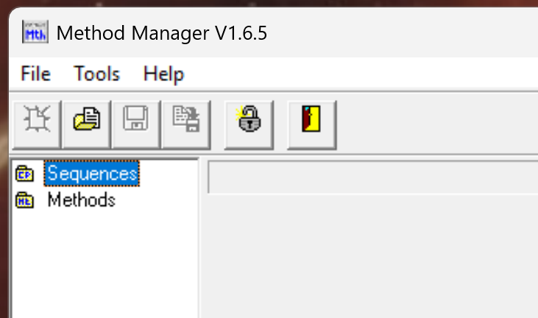

  - Select the relevant Concept file (i.e., 2311BOTH.Cpt) and press Open
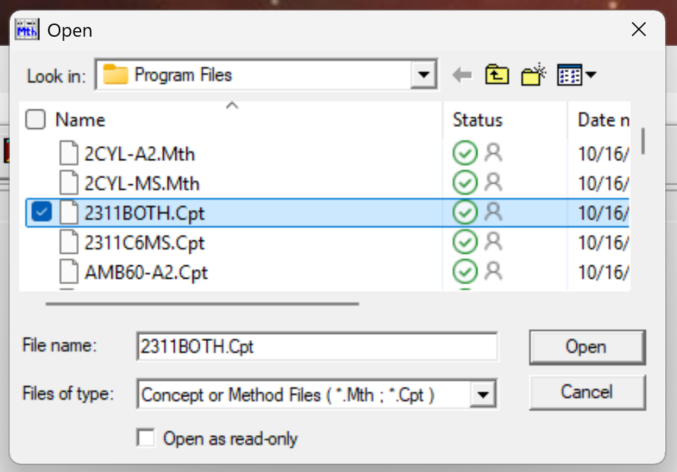
  - Expand the Sequence by pressing the plus button
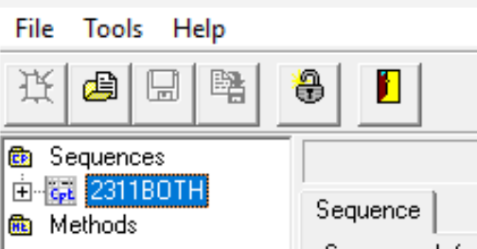
  - Click AMB60-A2
  - Go to “Program”
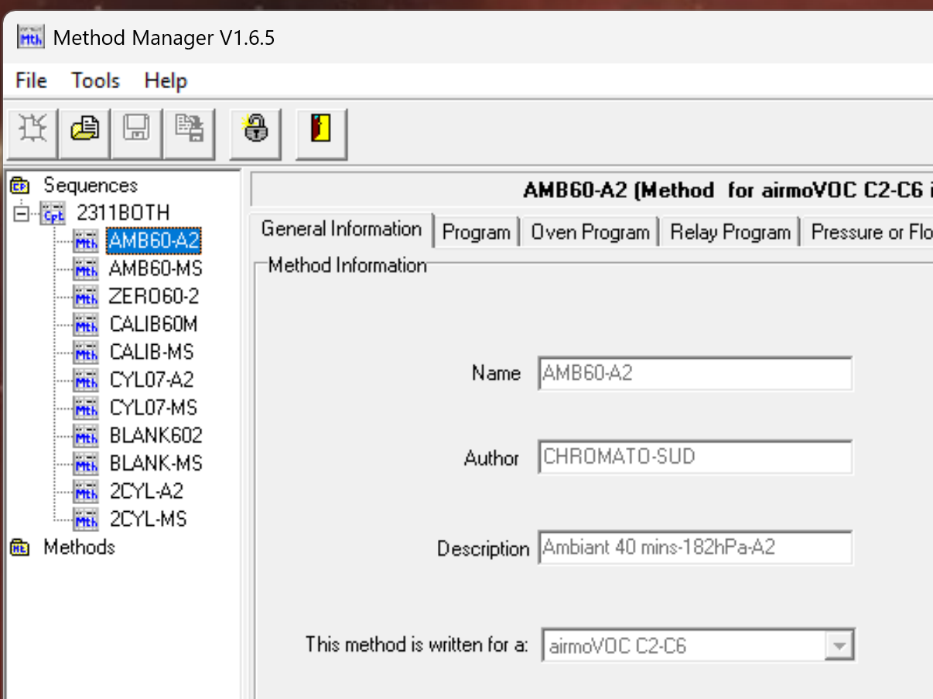

  - Click the 3 dots under the Substances table heading
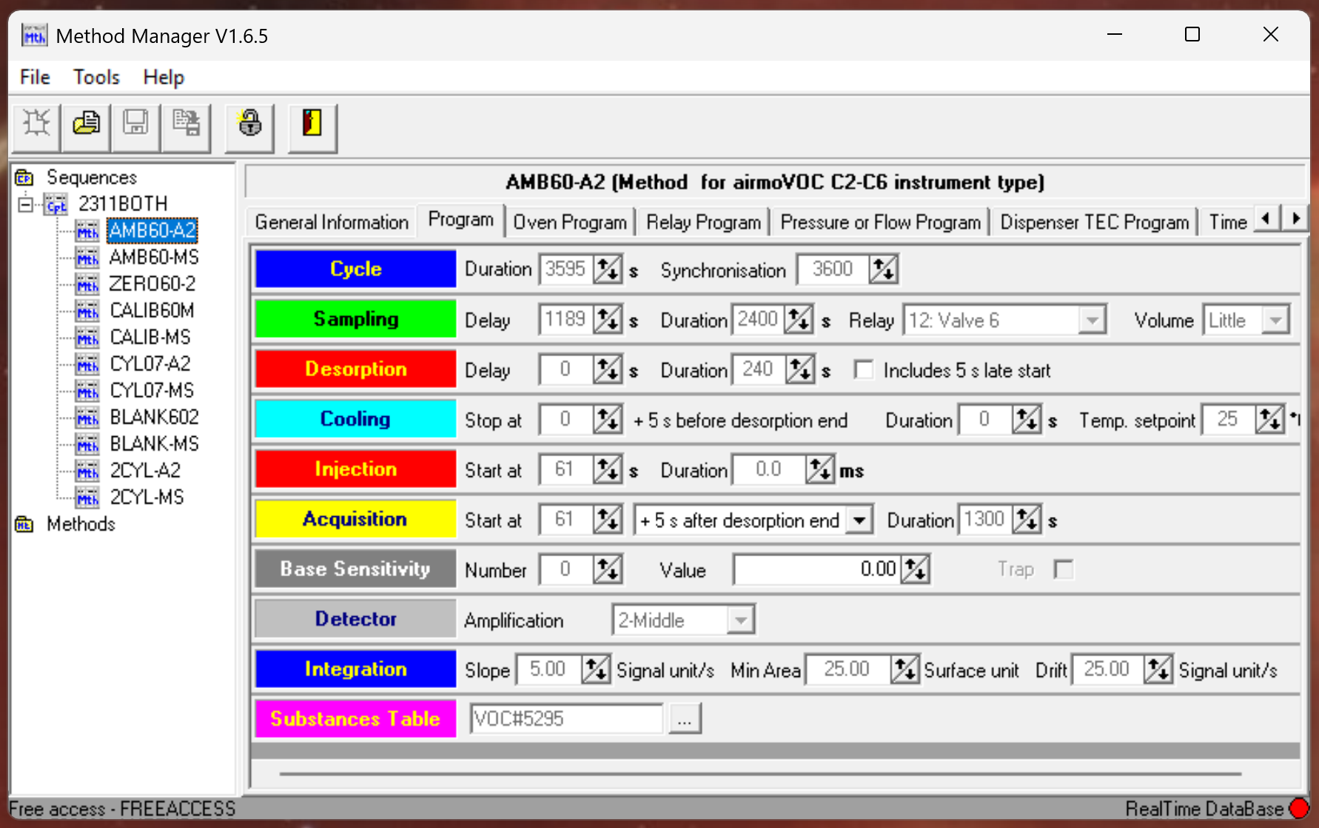
  - Load the reference Substances Table
    - Navigate to the folder containing Substances tables
    - Click the newest reference Substances table
    - Click Open
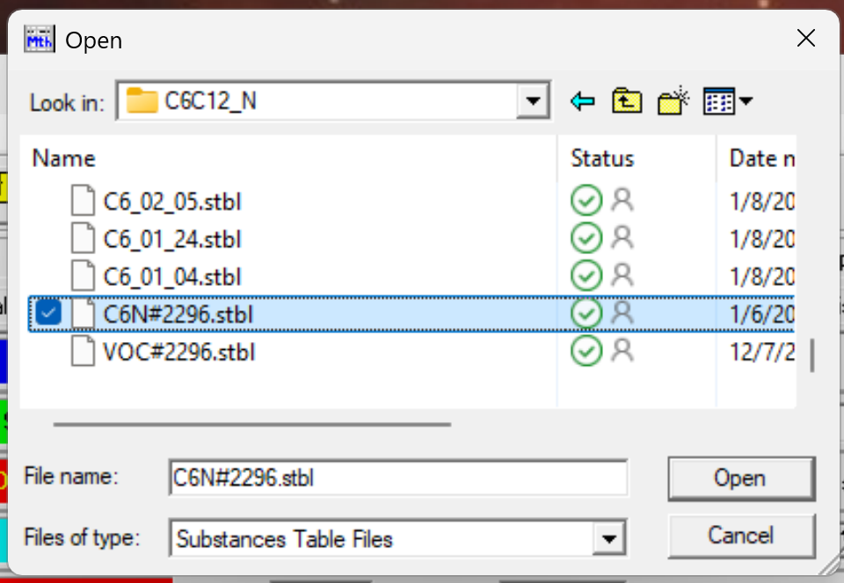
  - Open the reference Substances table by double-clicking on the name under Substances Table
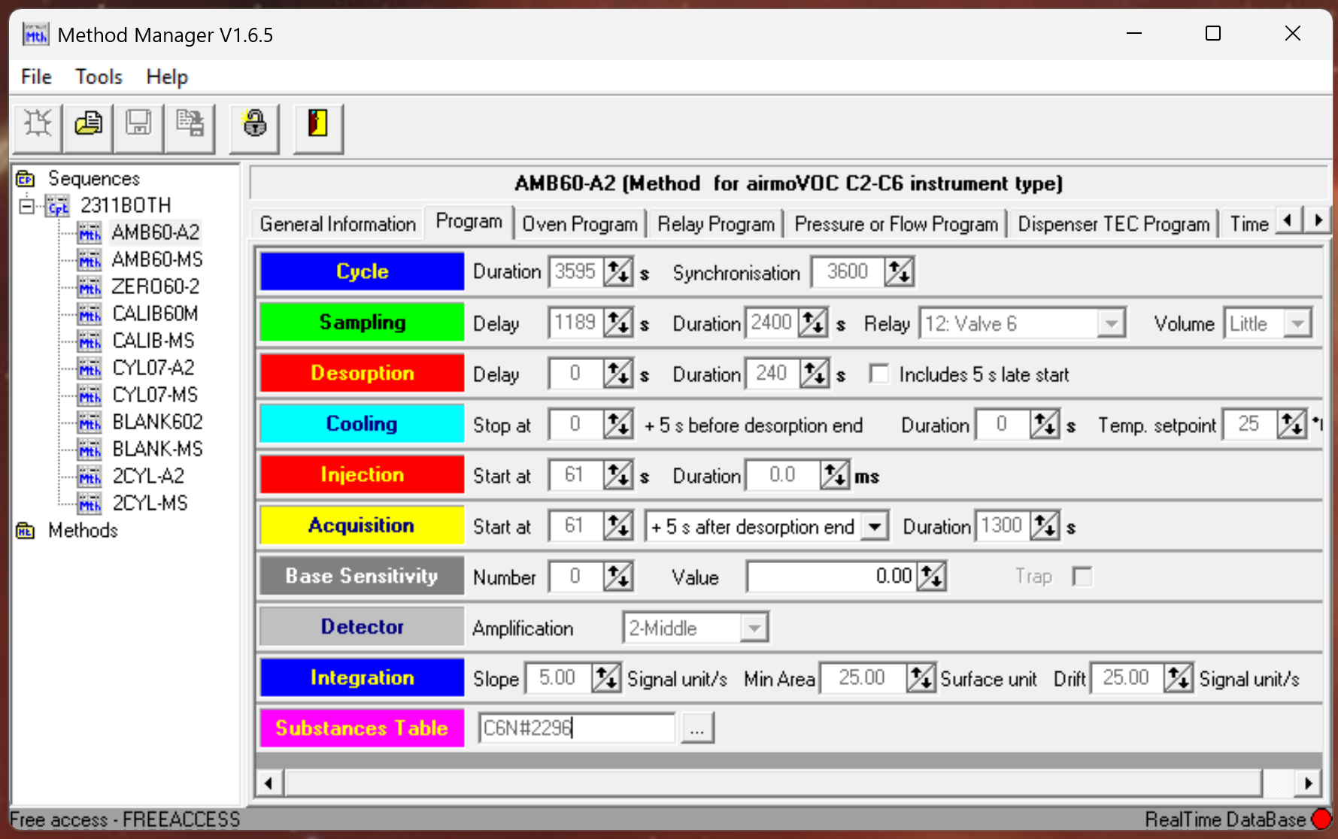
  - Save it as a new Substances table
    - Click the Save As button
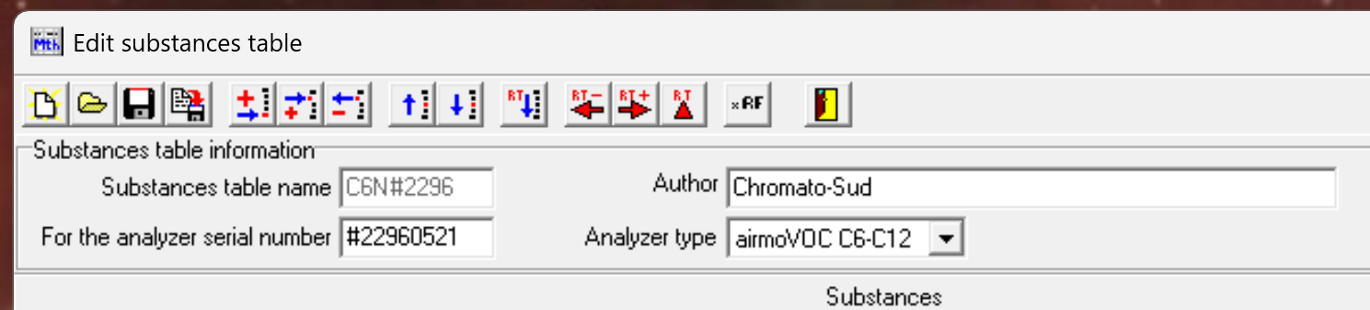
    - Navigate to the folder containing Substances tables
    - Suggested naming for C6C12 is C6_mm_dd.stbl, using the month and day corresponding to the date of the Representative cylinder for the Excel file you will use to edit the substance table
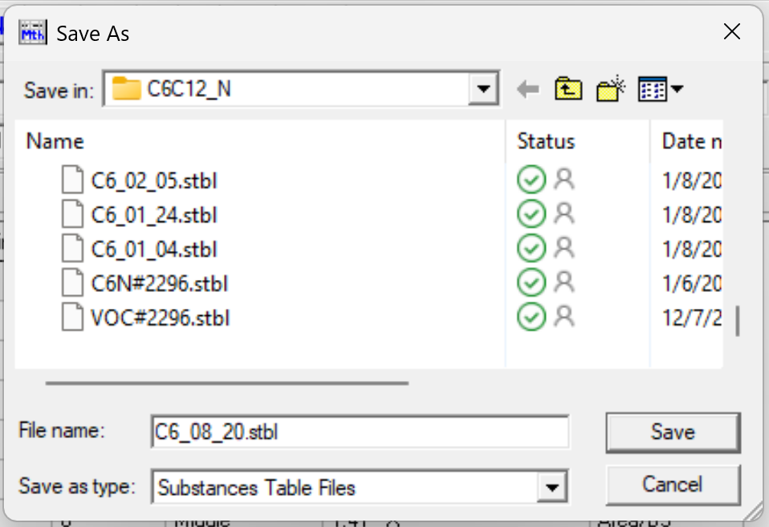
    - Click Save

- Manually edit a new substances table for each representative cylinder file
(skip this step if you use the Python automation)
  - The compounds are listed in order of expected retention time
  - For each compound name in the valid list (ID_cyl_peaks.csv)
    - Either double-click or press Enter to enable & to end editing mode
    - Input from the Excel sheet to the Substances table the calculated RT Min (column L) and RT Max (column M)
  - For each compound name NOT in the valid list (ID_cyl_peaks.csv)
    - Input 0 as the RT Min and RT Max
    - They have not been validated and will be excluded
  - Click the Save button when done
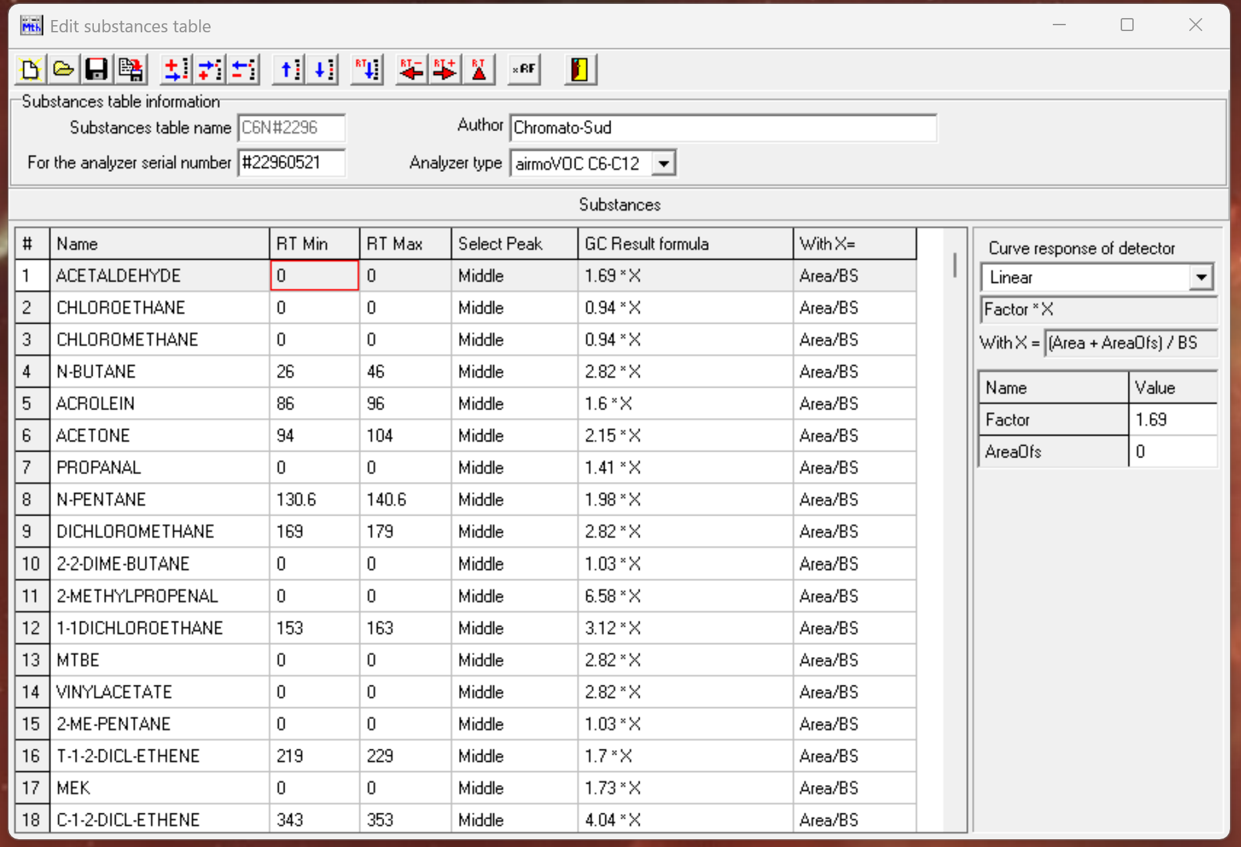
  - Repeat until all Substances tables are made
  - Close Vistachrom Method Manager software
- Optional: use the Python automation to make Substances tables for each representative cylinder file
  - Note: Python can be opened in IDLE, directly in the console (double click), or any Python workspace
  - Open methodmanager_rt_automation.py
    - Press “Esc” at any time to end the automation
    - If Vistachrom Method Manager is not open, it will report an error
  - Use compound type C6C12 by entering the number “2” (“1” for C2C6)
  - Press Enter
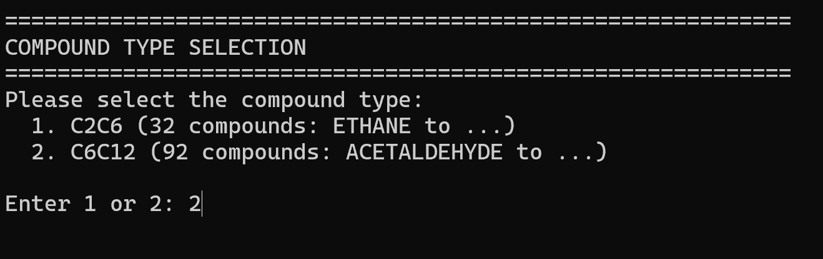
  - When prompted, select the Excel file with the rt ending in “_all.xlsx”
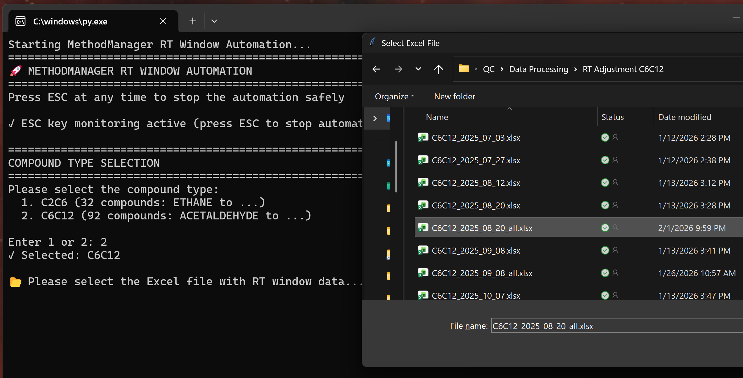
  - Press Open
  - You will be asked if everything is set up in Method Manager. Once you have verified that it is, type “y” & press Enter
  - You will be shown the Excel import and asked if compound values are correct. Once you have verified that it is, type “y” & press Enter
  - It will prompt you to return to Method Manager and click ACETALDEHYDE so there is a red box around it
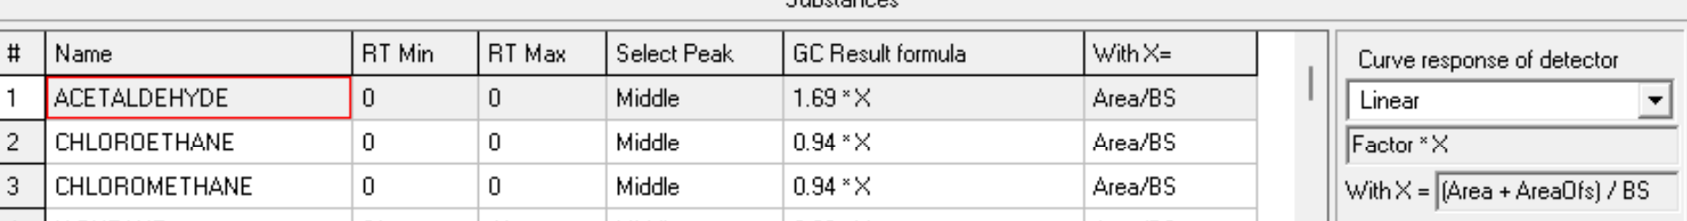
  - Return to the Python script and press Enter
  - During the 3-second countdown, reselect the Method Manager window
  - Wait for the automation to input values (~10 minutes)
    - You will see it selecting each cell and changing the values
    - If it is changing the wrong values
      - press Esc
      - reopen the original table (don’t save)
      - rerun the automation, making sure you select the “Edit substances table” window before the 3-second countdown finishes
    - When it is on the last compound and the highlight is no longer moving, it is done
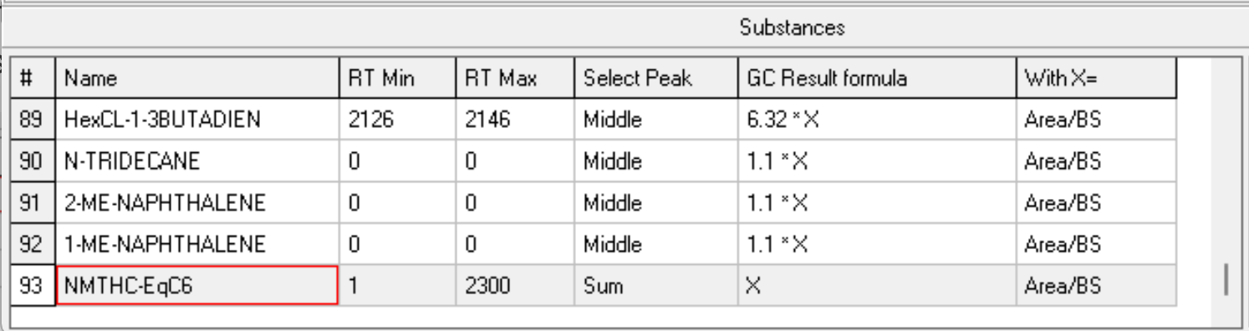
  - When the automation finishes, press the Save button

  - Repeat until all Substances tables are made

Re-exporting Data
- Export Revised data with the new Substances table
  - If data has already been exported for a time period, prior to re-exporting, move previous files for that time period to a different folder (i.e., a new folder named “old”) to avoid confusion (if they have the same name, they will not save separately nor properly overwrite)
  - Open Vistachrom Peak Viewer software

  - Load in all data for the date range between the “From Calib” calibration file and “To Calib” calibration file
    - Identify the date range
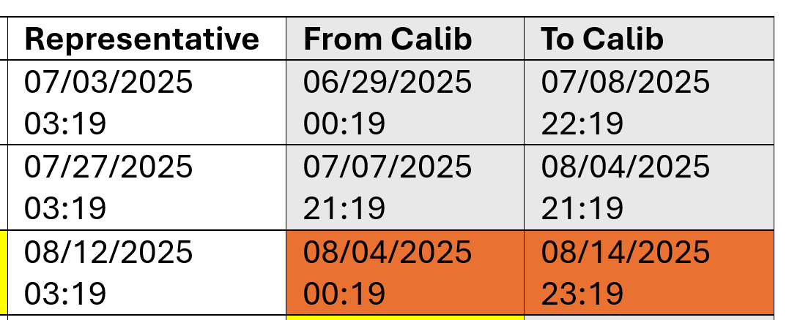
    - Optional: use date_organizer.py
      - Run the Python file
      - Put in path to folder containing GC/C6C12/mm/dd folders
      - Put in start date of the evaluation period as yyyy-mm-dd hh
      - Put in end date of the evaluation period as yyyy-mm-dd hh
      - All files in the period will be stored within GC/C6C12 folder
    - File -> Open (Alt+F, O)
    - Navigate to the folder
    - Select the files in the date range between and inclusive of the “From Calib” and “To Calib” Calibration files (i.e., files for all timestamps from 20250804_0019 through to 20250814_2319)
      - Note: It is easiest if files are sorted by date
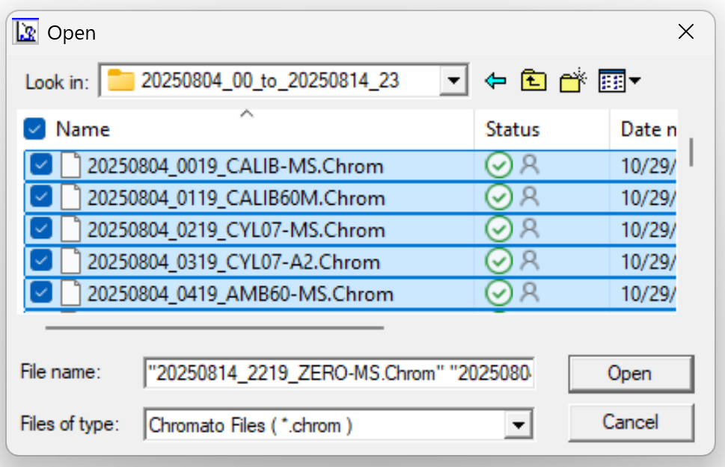
    - Click Open
  - Go to Post-Process (P)

  - Use the Substances table from the representative cylinder (i.e., C6_08_12.stbl)
    - Click the folder icon under “Substances table used”

    - Navigate to the folder
    - Select the Substances table corresponding to the “Representative” cylinder date in the date range table
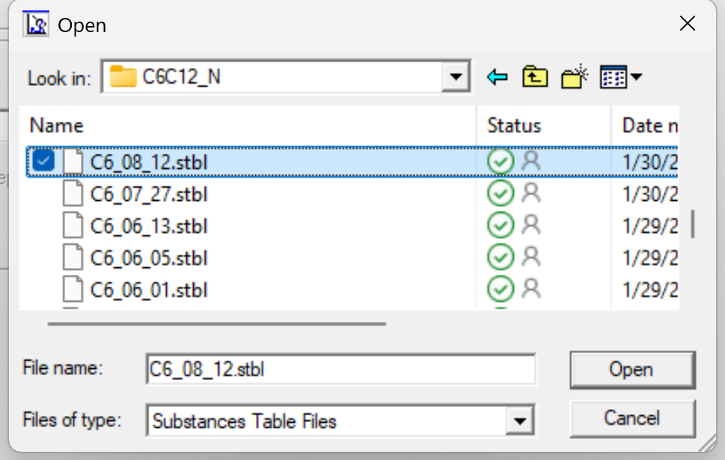
  - Under “Units used”, select “Unit Results” as “ppb(v)” (default is mg/m³)
  - Under “Post-Process type”, select “Post-Identification” and “Post-Correction”
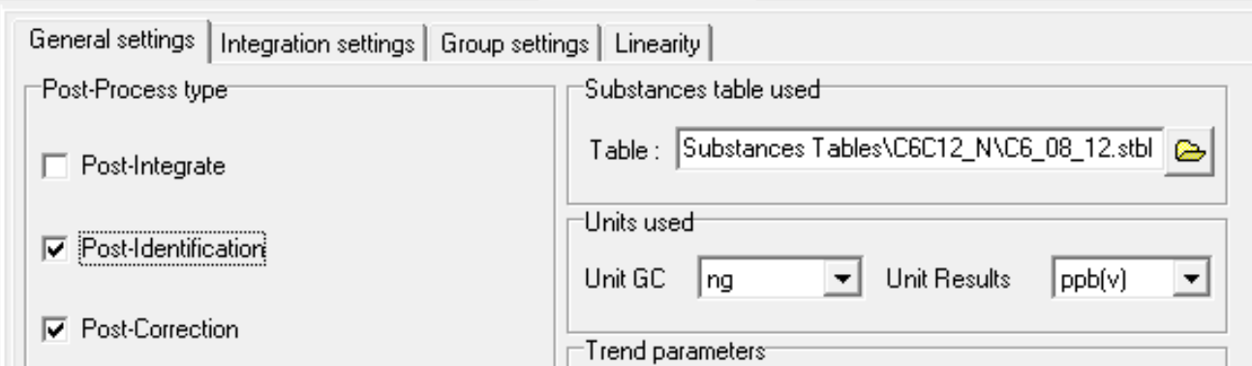
  - Export as Trend files under “Trend parameters”
    - Select “Create trend files” and “Select by Method”
    - Navigate to the folder
    - Set the name for the export to startdate_to_enddate as yyyymmdd_to_yyyymmdd, where “startdate” is the “From Calib” date and “enddate” is the “To Calib” date in the date range table
    - Click the Save icon
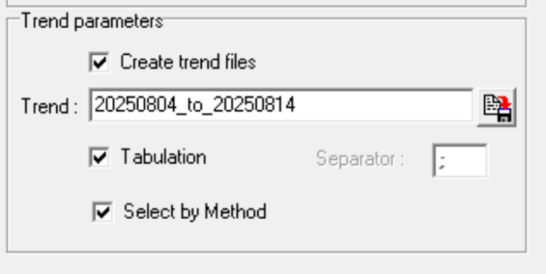
  - Click “Start Post-Process”
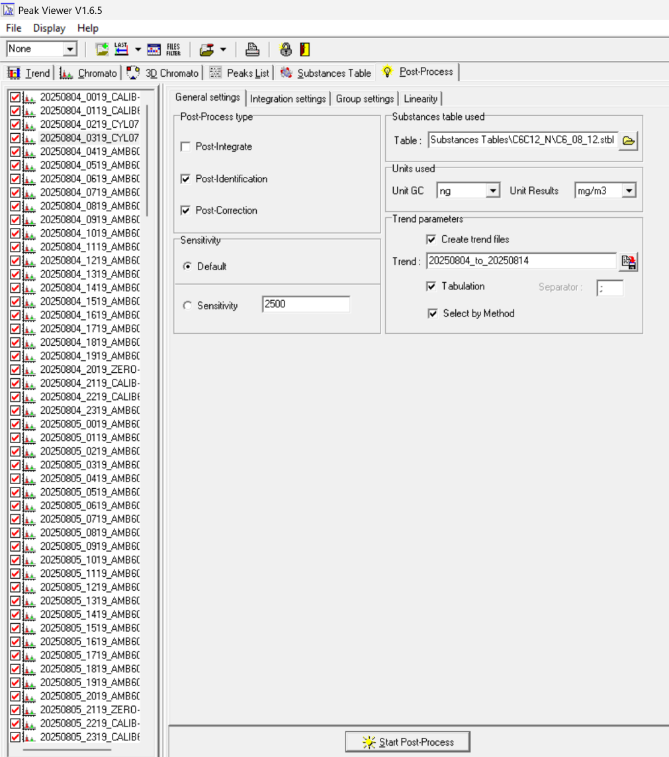
  - If needed, wait for the program to run (i.e., lots of data)

  - Check that the Cylinder peaks are now correctly identified
    - Return to Chromato view
    - Press Recalc to show the post-Substances table evaluation
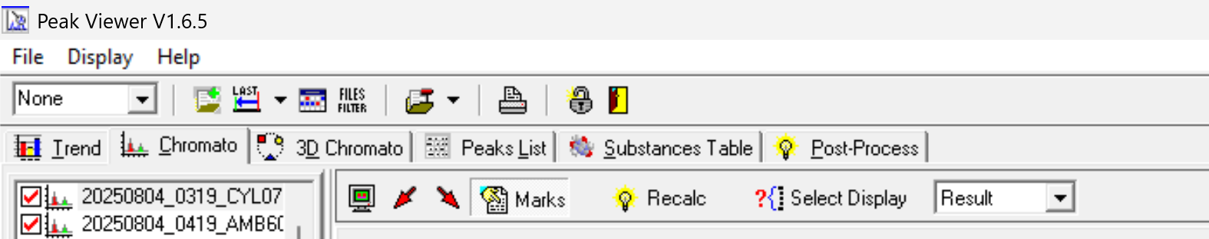
    - Select a cylinder file (CYL07-A2)
    - Do a preliminary, cursory examination to check that compound names are showing up as expected (i.e., the peaks have labels, and you see n-butane on the far left)
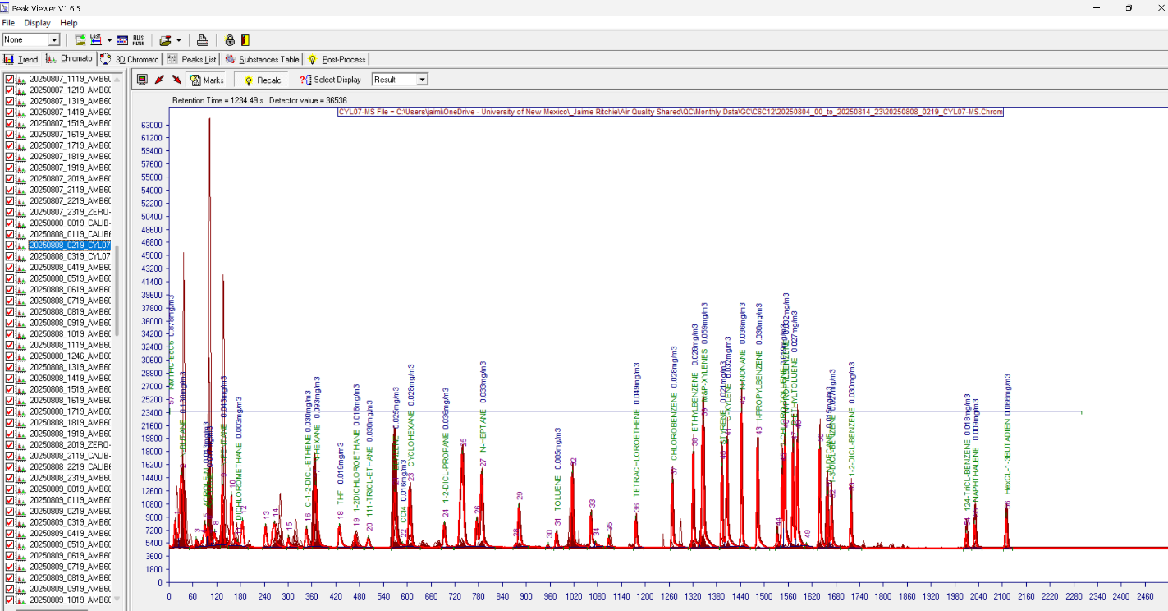
  - Verify that trend files are exported in the designated folder
  - Repeat the export process for all files in the date range period
  - Close Vistachrom Peak Viewer software
- Evaluate the Cylinder accuracy
  - Open cyl_asc_compare.Rmd in R Studio
    - Set cyl_folder to the folder path where the trend files were exported (line 43)
    - Set reference_file to the path for ID_cyl_peaks.csv (line 48)
    - Set output_folder to either cyl_folder or a separate folder (line 53)
    - Set compound_type (i.e. C6C12) (line 56)
    - Press Run All under Run

  - Check rtime_comparison_report.csv
    - Go to the folder location of your output_folder variable
    - Open rtime_comparison_report.csv
    - If perfect_match shows TRUE, the corresponding cylinder file and date are correct
    - Unexpected_list is a list of compound peaks that should not be identified
    - Missing_list is a list of compound peaks that should be identified
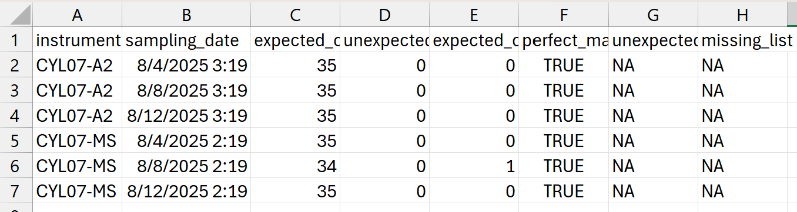
- Do the Cylinder files for the selected timeframe pass with perfect matches?
  - If yes, move on to the Management step
  - If no, repeat the Correction step until it does

Management of Data
- Download the following code and ensure the input directory is the folder of peak view exports, which should contain .Asc files that will be aggregated
Code | Input | Output | Evaluate
Combine_processed_data.Rmd | Directory with .Asc files | Combined .csv files by type | Files in Output folder
evaluate_0s.Rmd | Directory with .Asc files,  MDL file path | “No MDL exceedances” or “MDL exceedances” | If none, proceed. Else, exclude dates
amb_data_combine.Rmd | Directory with .Asc files | Combined Ambient .csv files | File in Output folder
MDL_replacement_keep34.Rmd | Directory with .Asc files,  MDL file path | Ambient .csv with 34 compounds and ½ MDL | File in Output folder
- Convert the .Asc files into .csv files
  - Open Combine_processed_data.Rmd
    - Put in the folder with peak view exports as the base directory, which should contain .Asc files (line 32)
    - Verify compound_type, change if needed (i.e. C6C12) (line 35)
    - Press Run All under Run
  - Ambient data in overlapping periods will either take the non-zero value, or, if both are non-zero, will be averaged
  - All cylinder results will be retained
  - All calibration results will be retained
  - All zero results will be retained
  - Files will be saved as .csv files to a subfolder titled “Output” in the base directory
- Verify that “Zero” files read 0 for valid compounds
  - Open evaluate_0s.Rmd
    - Put in the same base directory containing .Asc files (line 29)
    - Put in the path to MDL file (i.e., for C6C12 use MDL_ppb_C6C12_34c.csv) (line 33)
    - Verify compound_type, change if needed (i.e. C6C12) (line 35)
    - Verify MDL units, agree with the file (i.e., ppb) (line 36)
    - Press Run All under Run
  - The result should be “No MDL exceedances detected across all analyzed compound types.”
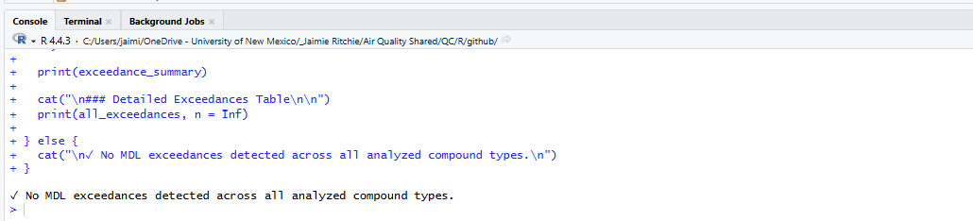
  - If the result displays MDL exceedances, exclude reported dates with issues
    - Determine which compounds are listed
    - Determine the datetimes associated with those compounds being falsely detected in the zeros file
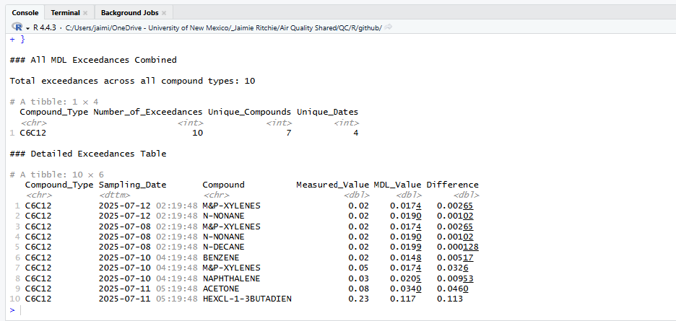
    - Check for corresponding false detections in ambient data rows of compounds reported as exceeding the MDL in times 24 hours before and after the zero file exceedance datetime
    - Exclude from ambient data analysis datetimes with false detections
    - Save a new file with those rows deleted
- Combine ambient data from MS and A2 (GC-FID) runs
  - Open and run amb_data_combine.Rmd
    - Put in the same base directory containing .Asc files (line 28)
    - It will export the combined file to the output folder
- Replace ambient data 0s with ½ MDL
  - Open and run MDL_replacement_keep34.Rmd
    - Put in the same base directory containing .Asc files (line 42)
    - Verify compound_type (i.e., C6C12) (line 45)
    - Put in the path to MDL file (i.e., for C6C12 use MDL_ppb_C6C12_34c.csv) (line 47)
    - Verify MDL units agree with the file (i.e., ppb) (line 48)
    - It will export the corrected file to the output folder with “_MDLrep,” keeping only the 34 valid compounds, with 0s replaced by ½ MDL

Post Instrument Recalibration
Note: this step is roughly annual and only needs to be completed post-recalibration
- Read GC-MS data file and get peaks
  - Validate the MS cylinder files
    - Suggestion: work with Curt Mowry at the UNM Chemistry Department for GC-MS validation
  - Obtain validated GC-MS cylinder calibration run for the timeframe of analysis
    - Note: Instrument changes can occur during maintenance and recalibration, so a new run is recommended each time that happens
- Check GC-FID peaks against GC-MS peaks
  - Reference Figure 3 for example comparison
    - Shows GC-FID and GC-MS chromatographs for the example time period of 540s – 840s as performed on the Jan 4, 2025 calibration run
      - Note that the GC-MS retention times are +120 seconds from GC-FID
  - Label peaks that directly align between GC-MS and GC-FID runs as “valid” and record names for future analysis
  - Label peaks with no corresponding response on the GC-MS as “unidentified”
  - Label peaks with more than 1 corresponding identification on the GC-MS as “ambiguous” and remove from the analysis due to low validity
  - Update EmptyC6C12_Revised.xlsx with valid peak retention times
    - Change retention times of existing peaks
    - If any valid compounds are reevaluated not as valid, delete corresponding lines
    - If any not-previously-valid peaks are reevaluated as valid, add lines for each peak using RT window information
- Create a new base Substances table
  - Open Vistachrom Method Manager software
  - For ambiguous and unidentified peaks, input 0 for the RT Min and RT Max
  - For valid peaks, input the RT Min and RT Max calculated based on the valid peak retention times
  - Close Vistachrom Method Manager software
- Take screenshots for comparison
  - Open Vistachrom Peak Viewer software
  - Open the cylinder run that was evaluated
  - Run the new Substances table on the file
  - Take screenshots
    - Of the full file
    - Of subsets
  - Save screenshots for future reference comparison
    - Can save a new version of Reference_cyl.pptx
  - Close Vistachrom Peak Viewer software

References
[1] “airmoVOC C6-C12 Expert.” Chromatotec, Oct. 15, 2020.

